

|  |  |
| --- | --- |
| **DELIVERED FRESH** | |
| Pretzel | $2.00 |
| Pretzel with Cheese | $2.50 |

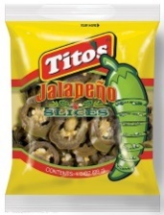

|  |  |
| --- | --- |
| **Nachos** | |
| Nachos with Cheese | $2.00 |
| Nachos with Cheese & Jalapenos | $2.50 |

|  |  |
| --- | --- |
| **From the Grill…** | |
| Hot Dog | $2.50 |
| Hamburger | $3.00 |
| Cheeseburger | $3.50 |

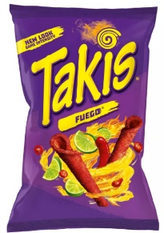

|  |  |  |
| --- | --- | --- |
| **Chips $1.00**  Rev 09/15/21 | | |
| Lays Classic | c |
| Doritos Nacho Cheese |
| Takis Fuego Hot Chili Pepper & Lime Tortilla Chips |

|  |  |
| --- | --- |
| **Drinks…** | |
| Aquafina Water | $1.00 |
| Soda | $2.00 |
| Gatorade | $2.00 |

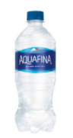

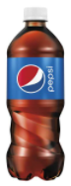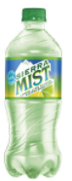

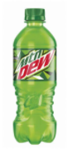

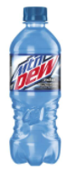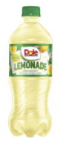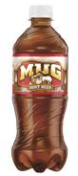

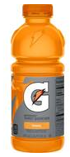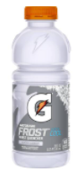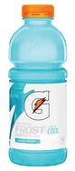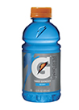

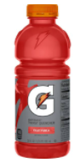



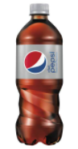

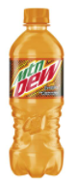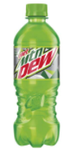

Rev 09/15/21

|  |  |
| --- | --- |
| **Snacks** | |
| Dill Pickle | $ .50 |
| Rice Krispies Treat | $ .75 |
| Slim Jim | $ .75 |
| Popcorn | $ 1.00 |

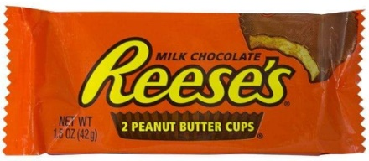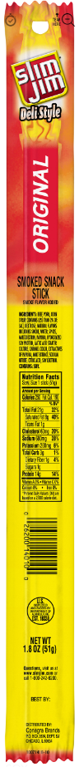

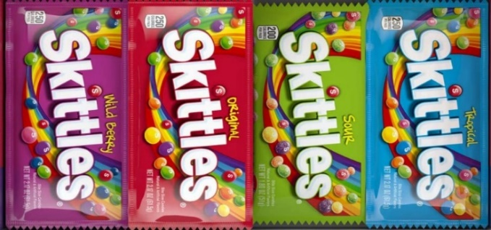

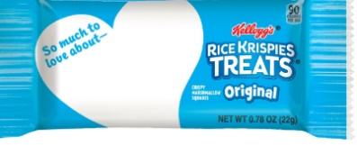

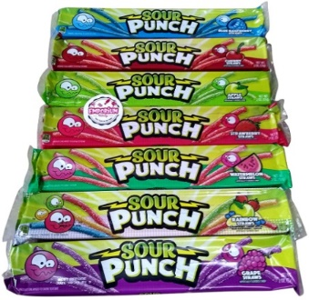

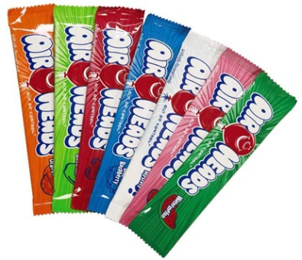

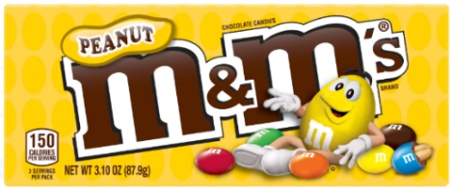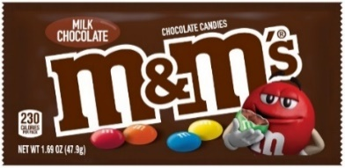

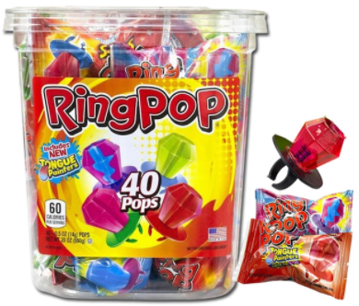

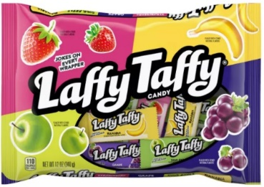

|  |  |
| --- | --- |
| **Candy** | |
| Blow Pop | $ .25 |
| Laffy Taffy | 2 for $.50 |
| Ring Pop | $ .50 |
| Airheads | $ .50 |
| Other Candy (*including* Airhead Extreme) | $1.00 |

Rev 09/11/21