**Substance Resources for Employees**

**Psych Hub**

Free learning at <https://psychhub.com/videos> , look for “Substance Abuse” under browse topic

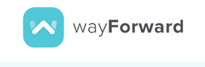

**Way Forward**

An emotional wellbeing app, with substance abuse resources, available for free to Parkway employees. Download in the app store and use code PARKWAY SD [Learn more](https://drive.google.com/file/d/1ln-HRTG_t-GpxD50E0RH5ZuoLZTC2N77/view?usp=sharing)

**Personal Assistance Services (PAS)**

PAS provides confidential, professional mental wellbeing support to help address challenges at home and at work.[**Learn more**](https://www.parkwayschools.net/cms/lib/MO01931486/Centricity/Domain/1481/Parkway%20EAP_wF.pdf) **or call 800-356-0845**

**Find Treatment, general:** <https://www.samhsa.gov/find-treatment>

**Substance Abuse Helpline:** 24-hour Substance Use Helpline 1-855-780-5955, [or learn more](https://www.uhc.com/individual-and-family/member-resources/health-care-programs/substance-use)

**Alcohol Use and Awareness:** [**learn more**](https://www.uhc.com/health-and-wellness/health-topics/substance-use-disorder/alcohol-awareness)

**How to find treatment on your Parkway UHC medical plan, step by step**

* Start at [www.myuhc.com](http://www.myuhc.com), log in
* Next, click on “Find Care and Costs”

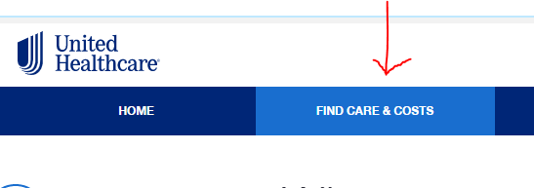

* Next, click on “Behavioral Health”

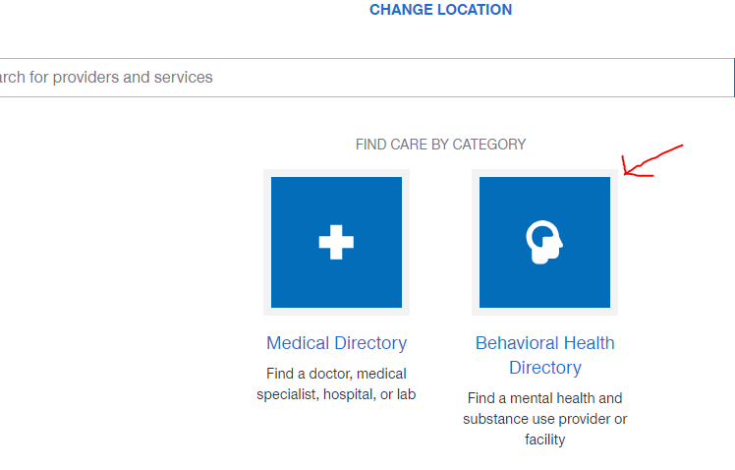

* Next, decide how you want to search. You can search based on condition (or provider or service)

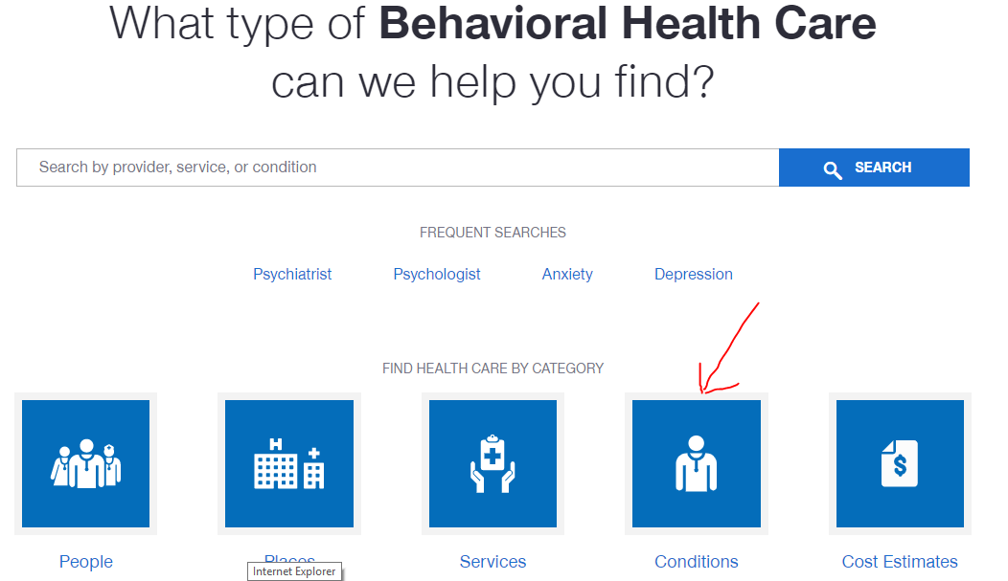

* Pick the first letter of the condition you are looking for. In this case, S for Substance Abuse.

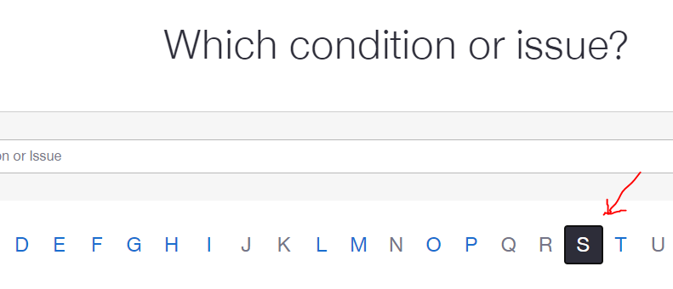

* Click on Substance Abuse

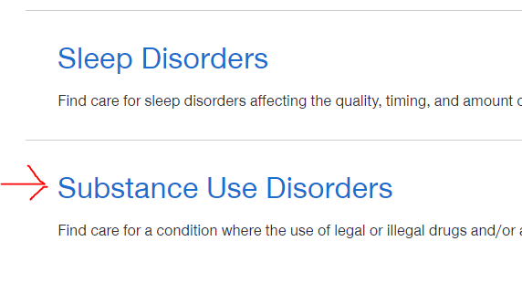

* Providers that you can contact will be located based on your area code