**ACT Prep- Math**

**Tips and Tricks**

*60 questions in 60 minutes. That means you get one minute per question!

*Answer every question!

**Introduction to Mathematics**

*You have 3 minutes to fill the following blanks, but you can only use the same number twice.

Positive numbers Whole numbers

______ _______ ______ ______ ______ ______

Negative numbers Integer

______ _______ _______ ______ ______ ______

Even numbers Factors- list the factors of 12

_______ _______ _______ ______ ______ _______

Odd numbers Multiples- list the multiples of 4

_______ _______ _______ _______ _______ ________

Product- What is the product of 2 and 12? Quotient- What is the quotient of 21 and 7?

______ ______

Prime- What is the smallest prime number? Real numbers

______ ______ _______ _______

Rational numbers Irrational numbers

_______ _______ _______ ______ _______ _______

**Percent**

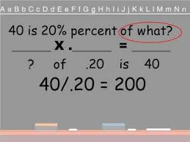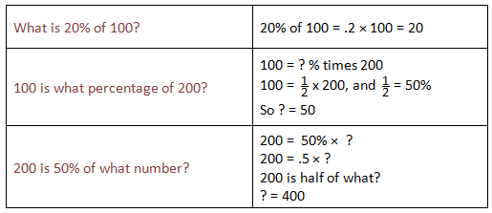**80 percent= 0.80**

Practice problems:

1) What number is 45% of 60? 2) 449 is 35% of what number?

3) 11 is what percent of 55? 4) What is 60% of 150?

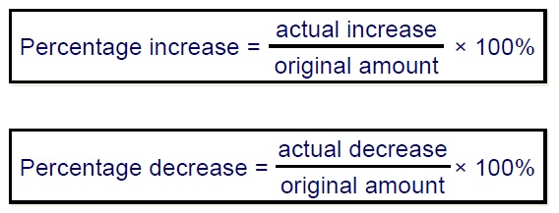**Percent Increase/Decrease**

Practice Problems:

1) A music store is having a going out of business sale. The first week the store marked down all the merchandise 30%. The second week the store marked down all the merchandise an additional 20%. If the price of a CD was originally $15, how much did the CD cost in dollars after all store mark downs were taken?

A) 7.50

B) 8.40

C) 9.10

D) 10.60

E) 12.00

2) The value of a house in 2006 was $80,000. If its value in 2007 is $85,000, but what % did the value of the house increase?

A) 6.25%

B) 9.4%

C) 5.88%

D) 2.75%

E) 6.75%

3) Keith’s portfolio is currently worth $10,200, representing a 20-percent increase on his original investment. How much did he originally invest?

(F)    $7,800

(G)    $8,160

(H)    $8,440

(J)    $8,500

(K)    $8,880

**Absolute Value**

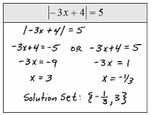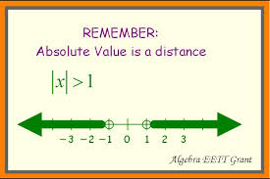

Practice Problems:

1) | -9+x| =3 2) -10 | x+2| = -70

3) 5- 8 |-2n| = -75 4) 3-|8x-6| = 3

5) What are the real solutions to the equation?

| x |2 +2 | x| -3=0

F. ± 1

G. ±3

H. 1 and 3

J. -1 and -3

K. ±1 and ±3

**Exponents and Roots**

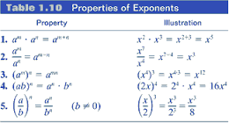

Examples:

1) 2) (x2)3 =

x7 * x3 =

3) 4)

3x3y * 4xy5 = 5x0 (-2xy)2 =

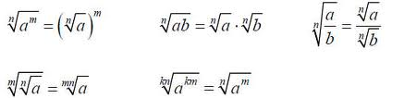

Simplify.

1) √200 2) 6√20 *3√30

3) 3√20 + √45 4) √2/√3

5) √72 6) 3√40-2√90+√10

**Factoring & Multiplying Polynomials**

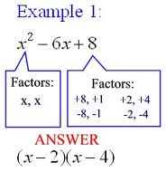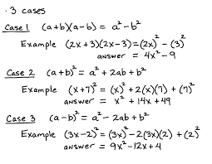

Quadratics Formula:

1) Simplify: 3(x-2) - 5(2x+4) 2) Multiply: (3x-2) (x+5)

3) Multiply: (2x+5) (x2 -3x-10) 4) Factor: x2 - x – 6

5) Solve: x2+2x+1=0 6) Solve: 4x2 +3x -9=0

**Functions-** A function relates an input to an output.

f(x)=…is the classic way of writing a function.

Domain: The set of all possible input values (often the “x” variable), which produces a valid output from a particular function.

Range: The set of all possible output values (usually the variable y, or sometimes expressed as f(x).

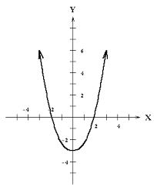

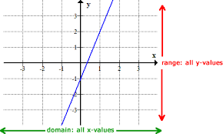

Examples:

Find the domain and range of each function.

a) y=x2 +4 b) y= (x-4)2 -2 c)y= √x d)y= -3x+4 e) $y={Log}_{3}\left(x+2\right)-3$

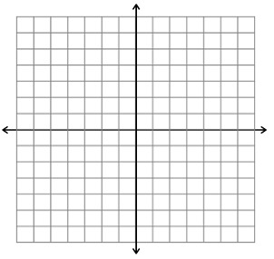

**Formulas to Remember!**

**Perimeter and Area**

Perimeter- Add up all the sides

Triangle: A=(1/2)bh

Rectangle: A=*l*\*w

Circle: A=πr2