**Accounting I  
Guided Reading**

**Chapter 4 Posting to a General Ledger**

**Objectives:**

* + **I will open accounts in a general ledger.**
  + **I will use the five step posting process to post separate amounts from a journal to a general ledger.**
  + **I will post column totals from a journal to a general ledger.**
  + **I will find and correct journal entries and general ledger postings.**

**4-1 Preparing a Chart of Accounts**

Relationship of a T Account to an Account Form

An account form includes the __________ and __________ sides of a T account.

Also a space is provided to put in the ___________ and ________________________. This information can be used to trace a specific entry back to where a transaction is recorded in a journal.

The form also must have an area where the up-to-date account balance can be recorded—referred to as the ______________________________.

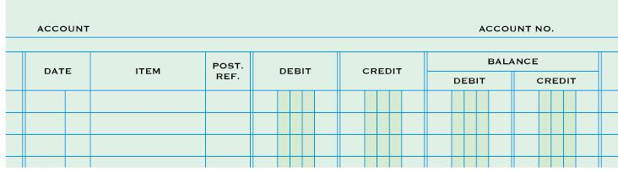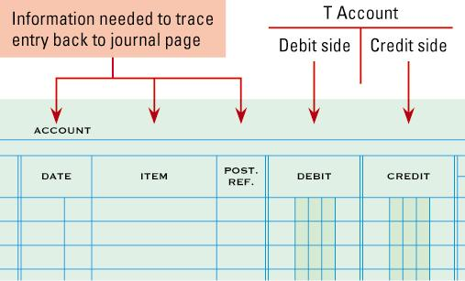

Balance columns

Chart of Accounts

Define Ledger:

Define General Ledger:

Define Account Number:

Define Chart of Accounts:

Five general Ledger divisions—  
(1)   
(2)   
(3)

(4)  
(5)

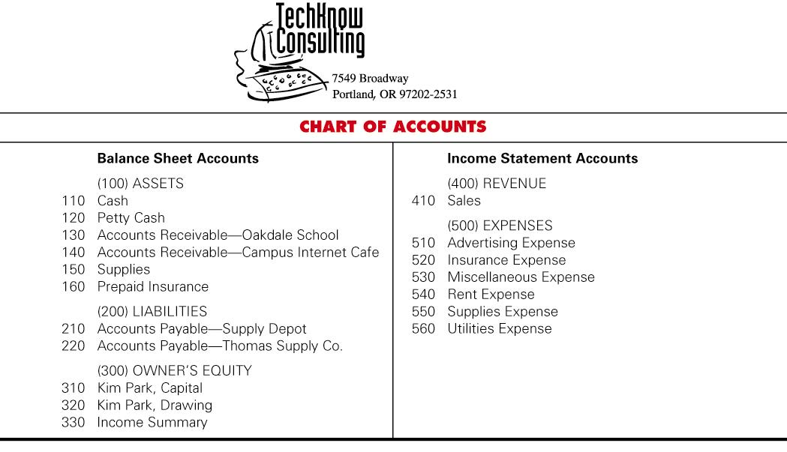Account Numbers

Triple Digit Account Numbers

First number shows: ___________________________________

Second two numbers show: _____________________________

Assign account numbers by ______________ so that   
_________________ can be added easily.

The procedure for arranging accounts in a general ledger, assigning account numbers, and keeping records current is called ___________________________________.

Opening an Account in a General Ledger

Writing an account title and number on the heading of an account is called ______________________________.

A general ledger account is opened for _____________________________ on a chart of __________________.

List the two steps for opening an account:

1.

2.

**4-2 Posting Separate Amounts from a Journal to a General Ledger**

Posting an Amount from a General Debit Column

Define posting:

List the five steps of posting from the general columns of a journal to the general ledger:

1.

2.

3.

4.

5.

Are the totals of the General Debit and General Credit columns posted? Why or why not?

The numbers in the “Post Ref.” columns of the general ledger account and the general journal serve three purposes:



**4-3 Posting Column Totals from a Journal to a General Ledger**

**Check Marks Show that Amounts Are Not Posted**

**Journal Entries that Are Not Posted Individually**

What symbol is used to indicate that a journal entry is not to be posted? __________________________

Two examples of journal entries that do not get posted are _____________________ and __________________

**Totals of General Debit and General Credit Amount Columns**

Why are the General Debit and General Credit columns not considered a special amount column?

___________________________________________________________________________________________

What symbol is used to indicate that the General Debit and Credit columns are not to be posted? ____________

**Posting the Total of the Sales Credit Column**

Which column totals of a journal are posted? ______________________________________________________

Using the following General Ledger page, post the column total for Sales Credit

|  |  |  |  |  |  |  |  |  |  |
| --- | --- | --- | --- | --- | --- | --- | --- | --- | --- |
|  |  | ACCOUNT | **SALES** |  |  |  | ACCOUNT NO. | **410** |  |
|  |  |  |  |  |  |  |  |  |  |
|  | DATE | | ITEM | POST. | DEBIT | CREDIT | BALANCE | |  |
|  | REF. | DEBIT | CREDIT |  |
|  |  |  |  |  |  |  |  |  |  |
|  |  |  |  |  |  |  |  |  |  |

**Posting the Total of the Cash Debit Column**

Using the following General Ledger page, post the column total for Cash Debit

|  |  |  |  |  |  |  |  |  |  |
| --- | --- | --- | --- | --- | --- | --- | --- | --- | --- |
|  |  | ACCOUNT | **CASH** |  |  |  | ACCOUNT NO. | **110** |  |
|  |  |  |  |  |  |  |  |  |  |
|  | DATE | | ITEM | POST. | DEBIT | CREDIT | BALANCE | |  |
|  | REF. | DEBIT | CREDIT |  |
|  |  |  |  |  |  |  |  |  |  |
|  |  |  |  |  |  |  |  |  |  |

**Posting the Total of the Cash Credit Column**

Using the previous General Ledger page, post the column total for Cash Credit

**4-4 Completed Accounting Forms and Making Correcting Entries**

**Journal Page with Posting Completed**

How do you know that a journal page has posting completed? _______________________________________

**Memorandum for a Correcting Entry**

What is a correcting entry? ____________________________________________________________________

___________________________________________________________________________________________

When is a correcting entry needed? _____________________________________________________________

___________________________________________________________________________________________

What source document is prepared when an error is discovered? _____________________________________

**Journal Entry to Record a Correcting Entry**

Using the following Journal Page 7, complete the November 13 transaction.

|  |  |  |  |  |  |  |  |  |  |  |  |
| --- | --- | --- | --- | --- | --- | --- | --- | --- | --- | --- | --- |
| **JOURNAL** | | | | | | | | | | **PAGE 7** | |
|  |  |  |  |  |  | **1** | **2** | **3** | **4** | **5** |  |
|  | **DATE** | | **ACCOUNT TITLE** | **DOC. NO.** | **POST. REF.** | **GENERAL** | | **SALES CREDIT** | **CASH** | |  |
| **DEBIT** | **CREDIT** |  | **DEBIT** | **CREDIT** |  |
| 1 |  |  |  |  |  |  |  |  |  |  | 1 |
| 2 |  |  |  |  |  |  |  |  |  |  | 2 |
| 3 |  |  |  |  |  |  |  |  |  |  | 3 |
| 4 |  |  |  |  |  |  |  |  |  |  | 4 |
| 5 |  |  |  |  |  |  |  |  |  |  | 5 |