**Accounting I  
Guided Reading**

**Chapter 5 Cash Control Systems**

**Objectives:**

* + **I will prepare a check stub, check, deposit slip, bank reconciliation and endorsements.**
  + **I will journalize entries for voided checks, bank service charges, dishonored checks, electronic funds transfer, and debit card transactions.**
  + **I will journalize entries to establish a petty cash fund and replenish a petty cash fund.**

**5-1 Checking Accounts**

**How Businesses Use Cash**

Money = __________  
Major payments are made by using a ________________.

Define Code of Conduct:

**Depositing Cash**

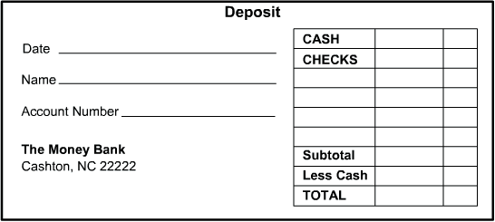Define checking account:

When a checking account is opened, the all people authorized to write checks from that account must provide a _____________________.

When you put money into your bank account, it’s called a ______________ and you fill out a _______________.

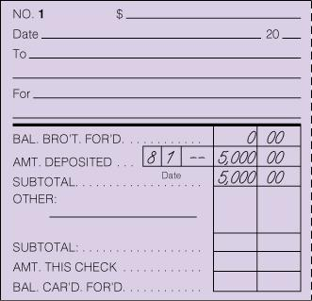A _____________ is given to customer each time a deposit is made.

**Deposit Recorded on a Check Stub**

Each time a deposit is made, it has to be recorded where? _____________________

**Blank Endorsement, Special Endorsement, and Restrictive Endorsement**

Define endorsement:

Define Blank Endorsement:

Define Special Endorsement:

Define Restrictive Endorsement:

Demonstrate:  
 Blank Endorsement Special Endorsement Restrictive Endorsement



**Completed Check Stub and Check**

6 Steps to completing a check stub—Go!

1. ____________________________________________________________________________________
2. ____________________________________________________________________________________
3. ____________________________________________________________________________________
4. ____________________________________________________________________________________
5. ____________________________________________________________________________________
6. ____________________________________________________________________________________

6 Steps to completing a check stub—Go!

1. ____________________________________________________________________________________
2. ____________________________________________________________________________________
3. ____________________________________________________________________________________
4. ____________________________________________________________________________________
5. ____________________________________________________________________________________
6. ____________________________________________________________________________________

Recording a Voided Check

Voided checks can occur when an __________ occurs in the writing of the check. If an error occurs the check is no longer _______________ to the bank.   
Because checks are numbered a ____________ must be kept of all checks.   
Write ______________ on all checks so they cannot be used  
  
Complete the steps to record a voided check in the Journal:

|  |  |  |  |  |  |  |  |  |  |  |  |
| --- | --- | --- | --- | --- | --- | --- | --- | --- | --- | --- | --- |
| **JOURNAL** | | | | | | | | | | **PAGE 1** | |
|  |  |  |  |  |  | **1** | **2** | **3** | **4** | **5** |  |
|  | **DATE** | | **ACCOUNT TITLE** | **DOC. NO.** | **POST. REF.** | **GENERAL** | | **SALES CREDIT** | **CASH** | |  |
| **DEBIT** | **CREDIT** |  | **DEBIT** | **CREDIT** |  |
| 1 |  |  |  |  |  |  |  |  |  |  | 1 |
| 2 |  |  |  |  |  |  |  |  |  |  | 2 |

**5-2 Bank Reconciliation**

What is a Bank Statement?

Give 4 reasons of why a bank’s records may differ from the customer’s records?

1. ______________________________________________________________________________________________________________________________________________________________________________________
2. ______________________________________________________________________________________________________________________________________________________________________________________
3. ______________________________________________________________________________________________________________________________________________________________________________________
4. ______________________________________________________________________________________________________________________________________________________________________________________

**Bank Statement Reconciliation**

If a checkmark is placed on the check stub of each cancelled check, what does a check stub with now check mark indicate? ____________________________________________________________________________________

10 Steps to a Bank Reconciliation:

1. Write the ____________
2. On the left, list the ______________________________
3. If there are any, record the _______________________
4. Write the _____________________________________
5. On the right side, write the ____________________________ shown on the _________________________
6. Write the ____________
7. Add (+) the bank statement balance to the _____________________________________________________
8. List the _________________________________ and ____________________________________________
9. Calculate ________________________________________________________________________________
10. Compare ________________________. The balances must _______________________________________

**Recording a Bank Service Charge on a Check Stub**

List the steps:



**Journalizing a Bank Service Charge**

Record the transaction on August 31-Received bank statement showing August bank service charge, $8.00 Memo No. 3.

|  |  |  |  |  |  |  |  |  |  |  |  |
| --- | --- | --- | --- | --- | --- | --- | --- | --- | --- | --- | --- |
| **JOURNAL** | | | | | | | | | | **PAGE 1** | |
|  |  |  |  |  |  | **1** | **2** | **3** | **4** | **5** |  |
|  | **DATE** | | **ACCOUNT TITLE** | **DOC. NO.** | **POST. REF.** | **GENERAL** | | **SALES CREDIT** | **CASH** | |  |
| **DEBIT** | **CREDIT** |  | **DEBIT** | **CREDIT** |  |
| 1 |  |  |  |  |  |  |  |  |  |  | 1 |
| 2 |  |  |  |  |  |  |  |  |  |  | 2 |

**5-3 Dishonored Checks and Electronic Banking**

**Recording a Dishonored Check on a Check Stub**

Define Dishonored Check:

Writing a check when it is insufficient (NSF) is __________________.

Having too many NSF checks can affect one’s __________________________________________.

Most banks charge a ______________ for handling a dishonored check.

Why might the bank dishonor checks?

1. NSF: ________________________________
2. Check appears to be ________________
3. Signature ___________________________ what is on file.
4. Amount written in figures and words ____________________________.
5. The check is _______________________________. Which means? (refer to section 5-1)____________ ____________________________________________________________________________________
6. The person who wrote the check _________________________________________________________

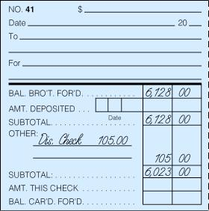Steps for recording a dishonored check on a check stub.

1. ___________________________________________
2. ___________________________________________
3. ___________________________________________

**Journalizing a Dishonored Check**

Record the transaction on November 29 on page 12 of the General Journal-Received notice from the bank of a dishonored check from Campus Internet Café, $70.00, plus $35.00 fee; total, $105.00. Memo No. 55.

|  |  |  |  |  |  |  |  |  |  |  |  |
| --- | --- | --- | --- | --- | --- | --- | --- | --- | --- | --- | --- |
| **JOURNAL** | | | | | | | | | | **PAGE 12** | |
|  |  |  |  |  |  | **1** | **2** | **3** | **4** | **5** |  |
|  | **DATE** | | **ACCOUNT TITLE** | **DOC. NO.** | **POST. REF.** | **GENERAL** | | **SALES CREDIT** | **CASH** | |  |
| **DEBIT** | **CREDIT** |  | **DEBIT** | **CREDIT** |  |
| 1 |  |  |  |  |  |  |  |  |  |  | 1 |
| 2 |  |  |  |  |  |  |  |  |  |  | 2 |
| 3 |  |  |  |  |  |  |  |  |  |  | 3 |
| 4 |  |  |  |  |  |  |  |  |  |  | 4 |
| 5 |  |  |  |  |  |  |  |  |  |  | 5 |

**Journalizing an Electronic Funds Transfer**

Define Electronic Funds Transfer (EFT):

What account Is credited when electronic funds transfer is used to pay cash on account?__________________

Record the transaction on page 12 of the General Journal- September 2, Paid cash on account to Kelson Enterprises, $350.00, using EFT. Memo No 10.

**Journalizing a Debit Card Transaction**

Define Debit Card:

What account Is credited when a debit card is used to purchase supplies?__________________

Record the transaction on page 12 of the General Journal- September 5, Purchased supplies, $24.00, using debit card. Memo No. 12.

**5-4 Petty Cash**

**Establishing a Petty Cash Fund**

Define Petty Cash:

Why do business use petty cash funds? ________________________________________________________  
 ________________________________________________________________________________________

Record the transaction on page 1 of the journal-August 19. Paid cash to establish a petty cash fund, $100.00. Check No. 8.

|  |  |  |  |  |  |  |  |  |  |  |  |
| --- | --- | --- | --- | --- | --- | --- | --- | --- | --- | --- | --- |
| **JOURNAL** | | | | | | | | | | **PAGE 1** | |
|  |  |  |  |  |  | **1** | **2** | **3** | **4** | **5** |  |
|  | **DATE** | | **ACCOUNT TITLE** | **DOC. NO.** | **POST. REF.** | **GENERAL** | | **SALES CREDIT** | **CASH** | |  |
| **DEBIT** | **CREDIT** |  | **DEBIT** | **CREDIT** |  |
| 1 |  |  |  |  |  |  |  |  |  |  | 1 |
| 2 |  |  |  |  |  |  |  |  |  |  | 2 |

**Making Payments from a Petty Cash Fund with a Petty Cash Slip**

What is a petty cash slip? ______________________________________________________________________

What information does a petty cash slip show?

1. _____________________________________

2._____________________________________

3. _____________________________________

4. _____________________________________

5. _____________________________________

6. _____________________________________

7. _____________________________________

**Replenishing Petty Cash**

Record the transaction on page 1 of the journal-August 31. Paid cash to replenish the petty cash fund, $30.00: miscellaneous expense, $20.00; advertising, $10.00. Check No. 12.