Name: ____________________________

**Accounting 1 Guided Reading**

**Chapter 6**

**Objectives:**

* + **I will prepare the heading and trial balance on a work sheet.**
  + **I will plan and record adjustments on the work sheet.**
  + **I will extend the account balances to the income statement or balance sheet of the work sheet.**
  + **I will calculate and record the net income or net loss on the work sheet.**
  + **I will total and rule the work sheet.**
  + **I will be able to find and correct errors on a work sheet.**

**6 – 1 Creating a Work Sheet**

*Consistent Reporting*

General ledger accounts contain information needed by managers and owners. Before the information can be used, it must be _____________________________________________.

Concept:___________________________________________________________________

*Fiscal Periods*

Definition of Fiscal Period: _________________________________________________

*A fiscal period can be 1 month, 3 months, 6 months, or1 year.

Concept for Accounting Period Cycle: ___________________________________________

___________________________________________________________________________

*Worksheet*

Four reasons accountants use a work sheet:

1. ________________________________________________________________________
2. ________________________________________________________________________
3. ________________________________________________________________________
4. ________________________________________________________________________

*Preparing the Heading of a Work Sheet*

Complete the heading of the worksheet for TechKnow Consulting

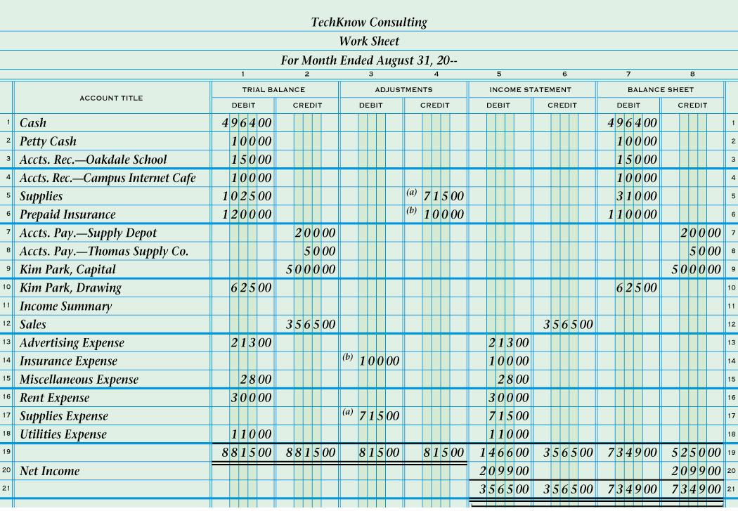

What would the 3rd line say if the fiscal period was one year?

**🡨 Name of** ___________________

**🡨 Name of** ___________________

**🡨 Date of** ________________

*Preparing a Trial Balance on a Worksheet*

Define Trial Balance:

Steps to Prepare a Trial Balance

1. _____________________________________________________________________________________
2. __________________________________________________________________________________________________________________________________________________________________________
3. _____________________________________________________________________________________
4. _____________________________________________________________________________________

Are you allowed to continue if the Debits and Credits don’t equal?_______________________________

1. _____________________________________________________________________________________
2. _____________________________________________________________________________________

**6 – 2 Planning Adjusting Entries on a Work Sheet**

*Planning Adjustments*

Concept of Matching Expenses with Revenue:

In order to give _______________________________ on financial statements, some general ledger accounts must be brought _______________________________________

________________________________________. (*Read paragraphs 2 – 3 on page 157)*

To plan adjustments you must ask yourself ____________________________________? That will be your _____________________________________.

*Supplies Adjustment*

Value of supplies used is calculated as:

Four questions are asked in analyzing the adjustment for supplies:

Record the Steps for the adjustment below.

1.

2.

3.

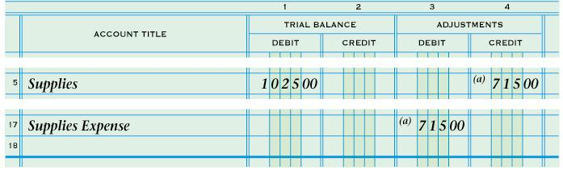

*Prepaid Insurance Adjustment*

Value of prepaid insurance used is calculated as:

Four questions are asked in analyzing the adjustment for prepaid insurance:

1.

2.

3.

4.

Record the Steps for the adjustment below.

1.

2.

3.

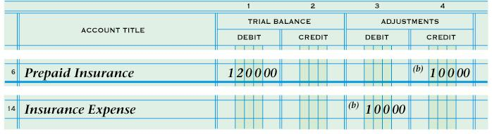

*Proving the Adjustments Columns of a Work Sheet*

After all adjustments are recorded in a work sheet’s adjustments columns, the equality of debits and credits for the two columns is proved by totaling and ruling the two columns.

Steps:

1. Rule a ____________ line
2. Add _________________________________________________ columns. If the two columns totals are the _________, then ____________________________________.
3. Rule __________________ lines across ___________________________________ .

**6 – 3 Extending Financial Statement Information on a Work Sheet**

*Extending Balance Sheet and Income Statement Account Balances on a Work Sheet*

At the ______ of each fiscal period, ______ financial statements are prepared from information on a __________________.

The balance sheet accounts are the ___________________________________________. Up-to-date balance sheet account balances are _______________ to the ______________ _________________________________________________________ of the work sheet.

Income statement accounts are the ___________________________________ accounts.

Up-to-date income statement account balances are _______________ to the __________ _________________________________________________________ of the work sheet.

*Recording Net Income/Net Loss, Totaling and Ruling a Work Sheet*

The difference between _______________________ and ______________________ when total revenue is greater is called ________________________. Before the worksheet is complete, _____________________________________________________ _______________________________________________________________________.



The difference between total revenue and total expenses when total expenses are greater is called __________________________.

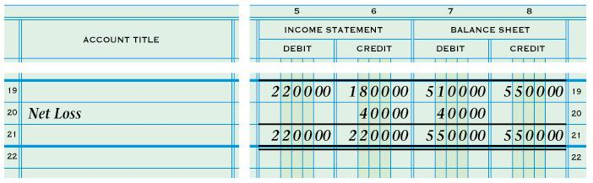

**6 – 4 Finding and Correcting Errors on the Work Sheet**

*Correcting Accounting Errors on a Worksheet*

Some errors in accounting records are not discovered until _______________________. For example, a ___________________________ may not have been posted from a journal to the general ledger __________________________.

Any errors found on a work sheet must be _____________________________________

_______________________________________________________________________.

*Checking for Typical Calculation Errors*

(Only write the bolded sentence for each)

*Correcting an Error in Posting to the Wrong Account*

Steps:

For example: Prepaid Insurance was incorrectly debited for $50 instead of Supplies.

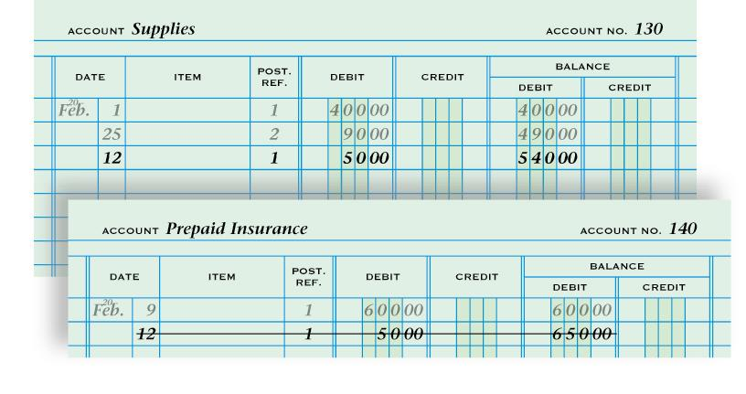

*Correcting an Incorrect Amount and an Amount Posted to the Wrong Column*

Steps to correct an Incorrect Amount (For example: $700 was written instead of $70):

1. 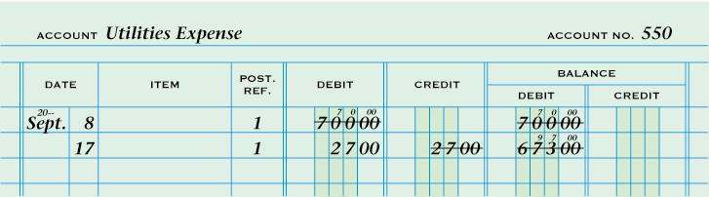

Steps to correct an amount posted to the Wrong Column (For example: $27 was written in the credit column instead of the debit column.):



*Checking for Errors in Journal Entries*

Ask 5 Questions:

1. Do _____________________________________?
2. Is each _____________________________________________________?
3. Is the ____________________________________?
4. Are the _______________________________________?
5. Have _________________________________________________________?