Budgeting Unit

1. Budgeting is defined as :____________________________________

**Building a Budget**

1. _______________________________

2. _______________________________

3. ______________________________

4. ______________________________

5. _______________________________

**Characteristics of a Successful Budget**

* ____________________________
* ____________________________
* ____________________________
* ____________________________

1. Budgets help you :
2. A good budget is:
3. P.Y.F. - _____________________________________________________________________ __________________________________________________________________________
4. The three largest parts of a budget are:

Cash Flow Statement

Def –

Income

Types of Income



Gross Income –

Disposable Income –

Discretionary Income -

Expenses

1. Expenses – Def –
2. Fixed Expense –
3. Variable Expenses –
4. Periodic Expenses

Standard Pay Check

Standard Paycheck

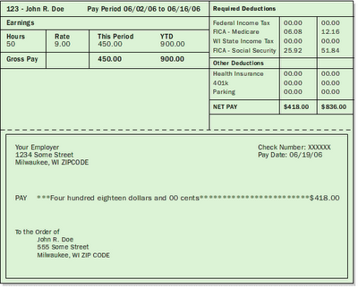

Gross Pay –

Deductions –

Two types –

1.

Example -

2.

Example –

Taxes

Federal Income Tax

FICA

State and Local Taxes

1. Money management –

Links for Budgeting Project

Step 1 – Finding Salary of a career <http://www.payscale.com/research/US/Country=United_States/Salary>

Step 4 - Salary Paycheck Calculator

<http://www.adp.com/tools-and-resources/calculators-and-tools/payroll-calculators/salary-paycheck-calculator.aspx>

Step 9B and 9C

<http://www.rentjungle.com/comparerent/>

Step 13

Transportation cost in St. Louis <http://www.metrostlouis.org/FaresPasses/FareChart.aspx>

Step 14

Car Payment - <http://www.edmunds.com/>

Step 15

Car Insurance - <https://www.thegeneral.com/quote/>

Step 29

Student Loan Debt

[http://ticas.org/posd/map-state-data-2015#overlay=posd/state_data/2015/mo](http://ticas.org/posd/map-state-data-2015)

1. Gross income
2. Net income
3. Assets –
   1. Examples are:
4. Liabilities –
5. Income:

|  |  |  |  |
| --- | --- | --- | --- |
| Salary | Hourly Wage | Overtime Rate | Commission |
|  |  |  |  |

1. Expenses ( Liabilities)
   1. These are things that we _________________

|  |  |  |
| --- | --- | --- |
| Fixed | Variable | Discretionary |
|  |  |  |

**Disposable Income**

**Gross**

**Pay**

1. Disposable Income -

**Disposable Income**

**Discretionary Income**

1. Discretionary Income –
2. ]]
3. Impulse Buying –
4. Unit Pricing –
5. Post Purchasing

|  |  |
| --- | --- |
| Rebate | Warranty |
|  |  |

1. Types of Warranties
   1. Full Warranty
   2. Partial Warranty
   3. Implied Warranty