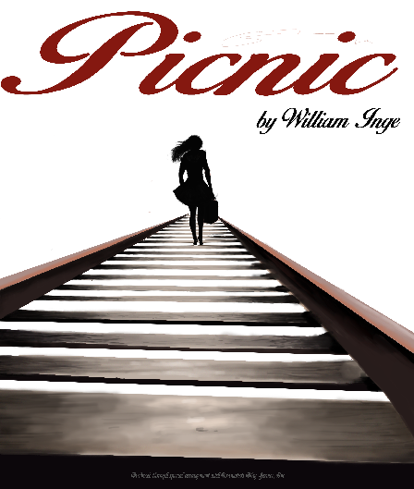

**Parkway Central High Theatre Dept.**

**Presents**

**PICNIC**

By William Inge

November 13-15, 2014

Picnic is presented by special arrangement with Dramatists Play Service, Inc.

Your Attention Please…

Once the show begins, entrance into the theatre will only occur during the scene changes.

Due to the nature of our set, please use the rear exits of the theater if you must leave during the show. However, for your safety, please remain in your seats once the show has begun.

Please keep the aisles clear of all personal items.

Please turn **ALL** electronic devices **OFF**.

**NO FLASH PHOTOGRAPHY OR VIDEOGRAPHY IS ALLOWED.** **The videotaping or other video or audio recording of this production is strictly prohibited.**

Concessions and production pictures on CD will be sold during intermission. Proceeds will benefit PCH Theatre Parents.

The raffle picnic basket winner will be pulled on Saturday, November 15. Tickets may be purchased before and during intermission.

Thank You,

PCH THEATRE DEPARTMENT



**PCH THEATRE DEPARTMENT – Troupe #1876**

PCH Theatre Parents 

The PCH Theatre Parents were founded during the 1996-1997 school year. The goals of this organization are to support the students’ activity in drama and educational theatre, to have representation on the PTO Board, to award scholarships to seniors, to increase attendance at productions, and, finally, to financially support the PCH Theatre Dept. by purchasing needed equipment or materials.

Without parent memberships at all levels and parent volunteers, those gifts would not be possible. If you have not become a member, please consider doing so by contacting one of the Co-Chair Theatre Parents. Thank you to all present members and to all volunteers for making this show and many more a success!

**Laurie Velasquez – President Rick Zucker - Treasurer**

**2014-2015 Season Subscribers**

A theatre subscriber is a person who continually supports our goal of achieving excellence in educational theatre with monetary donations. With these generous gifts, our Theatre Parents are able to help raise money for the annual theatre scholarship, awarded to a graduating senior. Thank you to all the following people for continuing to support theatre in our school!

|  |  |  |
| --- | --- | --- |
| **“PRODUCER”**  Lori & Chris Kertzman  David & Doris McCarter  Mauricio & Laurie Velasquez  Sandhya Yanamadala  Rick & Julie Zucker | **“CORPORATE**  **SPONSORSHIP”**  John & Sharon Kang | **“DIRECTOR”**  Dan & Jan Goldman  Janice and David Levine  Greg & Ruthy Wells |

The following people and organizations have contributed to make tonight’s performance a success. We thank them for their donations and generosity to the PCH Theatre Department.

Thank You

Props, Publicity and Parent Organization

Laurie Velasquez

Set Building and/or Painting

Corey Bys, Mark Cockerham, Rick Zucker and Michael Gottlieb

Rehearsal Dinners

Lori and Chris Kertzman, Jan Goldman, Ruthy Wells and Sharon King

Doug Gardner

Kent Gastrick

Abby Eisen

Todd Pannett

PCH Music Department

Parkway South High Theatre Department; Mrs. Jennifer Forrest-James

Parkway North High Theatre Department; Mr. Chad Little

Mrs. Moira McCracken

Westport Quick Print

The town of Cuba, MO and to the Cuba Free Will Baptist Church

Tropical Moose; Webster Groves and Walk Away Waffles Food Truck

SPECIAL THANK YOU TO…

PCH faculty and administration, especially:

Mr. Tim McCarthy, Mr. John Theobald, Mr. Jim Bundren & Cindy Burch

The Parkway Custodial Staff

*and*

Our families, who we love and appreciate:

Scott, Danielle, and Zachary Voss

*Please accept our sincerest apology if anyone was omitted from this list*

**Cast**

(in order of appearance)

Hal Carter……..….….….….………………………..….….…..….……………..Austin Sellinger

Helen Potts……..….….….………………………....….….….…..............…..Kaitlynn Ferris *

Millie Owens…...…………………..….….….….….....…………………..……..Tatiana Kobasa

Bomber…..….….….….….….….…………………..….………………….………..…...Alex Kaiser

Madge Owens……………………………..…………………………..……………....Emily Kang *

Flo Owens…………...….….…..….….…..….….……………..…………….Samantha Zucker *

Rosemary Sydney.….…….….……………………………………......Madeleine Van Leunen

Alan Seymour…………………………...…………….…………….……...Nathan Dettlebach *

Irma Kronkite……………………………..………………..……………………..…Joey Goldman

Christine Schoenwalder…………………………..……...……………..……..Nely Peshlova *

Howard Bevans…………………………...……………..……………..….Matthew Kertzman *

*\* Indicates a member of the International Thespian Society*

Synopsis of Scenes

Time: Labor Day weekend, 1952 Place: A small town in rural Kansas

Act 1: Monday morning

Intermission; 15 minuets

Act 2: Same day; late afternoon

Act 3: scene1: after midnight

scene 2: early the next morning

Production Staff

Director…………………………………….……………………………………………....Nicole Voss

Scenic Designer………………………………………………………………….Charles Winning

Dialect Coach…………………………………………Shanara Gabrielle and Katie Keating

Sound Engineer………………………………..………………………………...…Doug Gardner

Production Team

Production Stage Manager…………………………………………….………Joanna Kolker *

Company Stage Manager……………………….……………………………..….Maryan Hill *

Assistant Stage Manager................................................................Jessie Goldberg *

Scenic Designer…………………………………………………………….….Samantha Zucker *

Light Designer…………………….……………………………….………………….…Dillon Bys *

Sound Designer…………….……………………………………….………………Adam Cohen *

Costume Manager………………...……………………….……………..……Riley Cockerham

Makeup Manager……………….……………………..…………………..…….....Taylor Holton

Properties Manager……………………………….….……………………………….…..Mya Petty

Publicist……………………………………….……………………………………...Kayla Benjamin

Poster Artist………………………………..………………………………………Hannah Klepper

House Manager…………………………………….……………………..…Rebecca Velasquez *

*\* Indicates a member of the International Thespian Society*

|  |  |  |
| --- | --- | --- |
| SET  Joanna Kolker  Maryan Hill  Jessie Goldberg  Kaitlynn Ferris  Rebecca Velasquez  Emily Kang  Casey Muhs  Evan Mogley  Matt Edwards  Chaseston Coleman | PAINT  Joanna Kolker  Maryan Hill  Jessie Goldberg  Matthew Kertzman  Emily Kang  Evan Mogley  Ashley Priest  Sophie Orlet | LIGHTS  Chris Scully  Johnathan Scully  Nely Peshlova  Rebecca Velasquez  SOUND  Johnathan Scully |
| PROPS/RUNNING  Jenna Librach  Olivia Gottlieb  Evan Mogley | COSTUMES  Jenna Librach  Sophie Orlet  Olivia Gottlieb | PUBLICITY  Daishaila Williams  Noah Weidner |
|  | MAKEUP  Jenna Librach  Olivia Gottlieb  Sophie Orlet |  |

Production Crews

Cast Bios

**Nathan Dettlebach** (junior - Alan Seymour) Nathan has acted in many past plays/musicals, including Wait Until Dark, How to Succeed in Business Without Really Trying, and five of Central Middle’s plays. Aside from acting, Nathan maintains over a 4.0 GPA & teaches karate. Nathan would like to thank his parents for putting up with his inconvenient schedule and Voss.

**Kaitlynn Ferris** (senior - Helen Potts) Kaitlynn past theatrical experiences include the roles of Pamela Peabody in The Fox on the Fairway, Linda in Hard Candy, and Meredith Wilfred in Why Do We Laugh? She also serves as the PCH Players’ Vice President and Co-Captain for PCH’s improv team, Flyspace. Outside of theatre Kaitlynn is involved in UC Help and Peer Teaching. Her interests include music, animals, reading, and Kake. She would like to thank her beautiful family and friends for their undying support and source of happiness. She would also like to thank Voss, the cast and the crew for their use of talents and hard work for making this production happen.

**Joey Goldman** (junior - Irma Kronkite) Joey has acted in many other plays, including Night at the Wax Museum, Once Upon a Mattress, Small Actors, Epic Adventures in a Rinky Dink Art Museum, and Antigone. She also attended an acting camp called Midsummer Theatre, a program at the University of Indiana. She would like to thank Alex Kaiser and Madeleine for being awesome and for putting up with her all this time.

**Alex Kaiser** (freshman - Bomber) This is a Alex's first high school main stage role. His past theatrical experience include The Music Man, Honk! the Musical, The Westing Game, Seussical, Much Ado Out West, and tech for Greek Mythology Olymiaganza. He is the freshman secretary on student council, sings in *On The Rocks* the men’s a capella group, and is involved in his youth group, BBYO. He would like to thank his friends and family, the rest of the cast and crew, and Mrs. Voss.

**Emily Kang** (sophomore - Madge Owens) Emily has acted in five different shows in middle school, as well as last year’s production of Wait Until Dark. She is a member of ITS, a student council delegate, a member of Flyspace (Central’s improv team) and the PCH players Secretary. She would like to thank her parents, for being endlessly loving and supportive, even when she’s at her worst; her boyfriend, Josh, for bringing her flowers, giving her hugs, and being her best friend; and Voss and the cast and crew for being a delight to work with.

**Matthew Kertzman** (junior – Howard Bevans) Matthew has been doing theatre since he was eight and has been in many productions. His favorite production at Central has been The Fox on the Fairway. Next month he will be appearing as Link in Hairspray at Gateway Center for the Performing Arts. He would like to thank all the wonderful cast and crew and his family.

**Tatiana Kobasa** (sophomore - Millie Owens) Tatiana is a PCH Player and is working towards becoming an ITS member. Tatiana loves to be with her friends and do crafty things. She would love to thank her parents and her friends for all the love and support that they have gave to her and hopes that you enjoy the show!

**Nely Peshlova** (junior - Christine Schoenwalder) In the past, Nely acted in The Diviners, How to Succeed in Business Without Really Trying, as well as two senior-directed one acts including My California. Nely really loves art, and she is the co-captain of Flyspace, the PCH improv team. She would like to thank her mom for forcing her to audition for her first middle school play and helping her realize that she loved it, and everyone involved in this production for being amazing.

**Austin Sellinger** (senior – Hal Carter) This is Austin’s fourth show at PCH. Other credits include Wait Until Dark, How to Succeed in Business… and The Diviners. Austin is also involved in Pizzazz, enjoys ultimate Frisbee and plays/sings in his band, *JUICE*. He would like to thank his mom, dad, his Mima, Joe, Pappa, Michaela Quist and Voss.

**Madeleine Van Leunen** (junior - Rosemary Sydney) Madeleine is making her debut role in Picnic. She is involved in PCH Players and Parkway Central’s Concert Choir. She also takes private voice lessons through Webster University and does a lot of volunteering outside of school. She would like to thank her mom and dad. Without them, she wouldn’t be where she is today. She also wants to thank her Grandfather because he always encouraged her to explore the Arts and to go above and beyond.

**Sami Zucker** (senior - Flo Owens) Sami is not only in Picnic, but she is also the Scenic Artist. Sami gave a Cappies-nominated performance for best ensemble as Marion Hollander in Don’t Drink The Water, performed at the 2013 Missouri State Conference as Norma Henshaw in The Diviners, was Cappies-nominated for featured dancer in How To Succeed in Business Without Really Trying, and was the Cappies-award winner for lead actress in a play as Susy Hendrix in Wait Until Dark. Sami was also featured in a number of senior-directed one acts, and will be directing her own one act in the spring of 2015. She is the proud President of Central’s drama club, the PCH Players. Sami loves working with kids, and volunteers at the Crisis Nursery. Sami would like to thank her family-- Sophie Z, Julie Z, Ricky Z, and Gilly Z. She would also like to thank her friends-- C-line (suh-LEEN!), B-ridge (and Frasier), (my) Anniconda (don’t), Michelle Bennett, Kylosher, and Jacqueline. Finally, Sami would like to thank Voss and her theatre family. You the real mvps.

Support the Performing Arts and.... 

HAVE A SEAT !

As a fundraiser for the Music and Theatre Departments, you have an opportunity to “purchase” a seat as a lasting tribute to your favorite musician, singer, band member, thespian, family member or friend!

Brass nameplates will be permanently attached to each Donor’s seat. This can be a great tribute to a loved one, and makes a perfect holiday, birthday or graduation gift. Today, tomorrow and many years from now, whenever you come to enjoy Central’s productions, your “signature” seat will still be there. What a great honor to remember that special child, teacher, friend or relative!

The cost is only $100 each, which is a **tax-deductible contribution**. Please make checks payable to the PCHS Seat Fund. Proceeds go toward the Orchestra, Band, Choir and Theatre Departments. A personal certificate is provided with each donation. Share the excitement for excellence in performance art at PCHS and “have a seat!”

Order forms can be found in the lobby during intermission or after the performance. Complete the order form and returned to Mrs. Voss in the Theatre Department.

**\*\*\*\*\*\* Remember to ask your employer to match your donation with the “Matching Gift Program”. \*\*\*\*\*\***

Musical Auditions:

Upcoming Events

g Events

MARY POPPINS

November 19-21, 2014

PCH Theater/Choir room

ORCHESTRA CONCERT

Nov 24, 2014 7:30 pm

PCH Theater

IMPROV SHOW

December 3, 2014

Theater 7:00 pm

BAND CONCERT

December 10, 2014

Gym A 6:00 pm

MO STATE THESPIAN

CONFERENCE

January 7-10, 2015

Spring Musical:

MARY POPPINS

Feb 26-28, 2015 7:00 pm

March 1, 2015 2:00 pm

IMPROV SHOW

April 1, 2015 7:00 pm

JOINT INDUCTION

April 7, 2014 7:00 pm

PCH Theater

JAZZ BAND CONCERT

April 9, 2015 7:30 pm

PCH Theater

RUMMAGE SALE

April 11, 2015 7am-5pm

(April 12 rain date)

PCH parking lot

SENIOR DIRECTED ONE ACTS

April 15, 2015 7:00 pm

PCH Theater

PIZZAZZ SHOW

April 23, 2015 7:30 pm

PCH Theater

ORCHESTRA CONCERT

April 30, 2015 7:30 pm

PCH Theater

THEATRE DEPT. BANQUET

May 1, 2015

PCH Commons 6:30 pm

BAND CONCERT

May 4, 2015, 7:30 pm

PCH Theater

CHOIR CONCERT

May 5, 2015, 7:30 pm

PCH Theater

AWARDS NIGHT

May 7, 2015 7:30 pm

MUSIC DEPT. BANQUET

May 11, 2015

PCH Commons 6:30 pm

DANCE CUP FUNDRAISER

May 15-17, 2015

Logan College

All events take place in the PCH Theater unless otherwise noted.

**For more information or to purchase tickets:**

**PCH Theatre Dept. 314-415-7940**

**PCH Box office: 314-415-5944**

**PCH Music Dept. 314-415-7911**



*….where theatre is a tradition!*

**1989-1990**

Cinderella

Romeo and Juliet

**1990-1991**

Anything Goes

Harvey

**1991-1992**

Alice In Wonderland

**1992-1993**

The Wizard of Oz

Oklahoma!

**1993-1994**

Tom Sawyer

**1994-1995**

Sleeping Beauty

Guys and Dolls

**1995-1996**

The Hobbit

A Time To Play

**1996-1997**

You Can’t Take It With You

South Pacific

The Diviners

**1997-1998**

Harvey

The Crucible

**1998-1999**

The Pirates of Penzance

The Grapes of Wrath

**1999-2000**

Noises Off

The Miracle Worker

MSHSAA – Baby With the Bathwater

**2000-2001**

Brighton Beach Memoirs

A Little Night Music

MSHSAA – When God Comes to Breakfast

**2001-2002**

The Man Who Came To Dinner

**2002-2003**

The House of Blue Leaves

Anything Goes

Dinner Theatre: “Critical Review”

MSHSAA – Home Free

**2003-2004**

Lend Me A Tenor

Bus Stop

**2004-2005**

The Musical Comedy

Murders of 1940

West Side Story

**2005-2006**

Laughter on the 23rd

Floor

To Kill A Mockingbird

**2006-2007**

See How They Run

Thoroughly Modern

Millie

**2007-2008**

Moon Over Buffalo

Death of a Salesman

**2008-2009**

The Elephant Man

Oklahoma!

**2009-2010**

The Prime of Miss Jean Brodie

The Mousetrap

MSHSAA – You Can’t Buy Me Love

**2010-2011**

Leading Ladies

Dirty Rotten Scoundrels

MSHSAA – Your Life is a Feature Film

**2011-2012**

Don’t Drink The Water

The Diary of Anne Frank

MSHSAA – Cemeteries are a Grave Matter

**2012-2013**

The Diviners

How To Succeed in Business W/O Really Trying

MSHSAA – Promageddon

**2013-2014**

Wait Until Dark

The Fox on the Fairway

**2014-2015**

Picnic

Mary Poppins



***Superintendent of Schools***

Dr. Keith Marty

***Fine Arts Coordinator***

Mr. Jeff Lackey

|  |  |
| --- | --- |
| ***PCHS Administration***  Principal……….…Mr. Timothy H. McCarthy  Assistant Principal……..….Mr. Chris Dallas  Assistant Principal.…….....Dr. Sarah Power  Assistant Principal..…..…….Mr. Travis Fast  Assistant Principal…...…Dr. Carletta Harlan  Activities/Athletics …......Mr. John Theobald | ***Parkway Board of Education***  President………………..…....Beth Feldman  Vice-President…….………….…Chris Jacob  Director……………………..Kim Appelbaum  Director………...…..………Tom Appelbaum  Director.……………………..Dee Mogerman  Director.……………..……..Deborah Hopper  Director…………..…...…..Dr. Sam Sciortino |

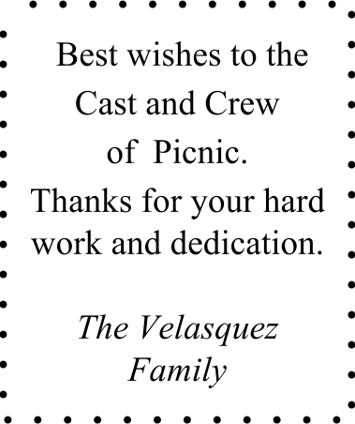

The Parkway Central High School Theatre Parents Organization

Congratulates

the

Cast and Crew

of

PICNIC

Having a birthday party? A Bar Mitzvah? Or anniversary? Are you looking for some creative entertainment? Then look no further...

FLYSPACE

is your answer to a fun, creative and easy way to entertain your guests

**FLYSPACE** is Parkway Central High’s **IMPROV team** and they can be rented out for performances for any length and any occasion.

Let **FLYSPACE** get your guests up on their feet and involved in this audience participation comedy event where the fun never ends!

For more information, contact Nicole Voss, 314-415-7940

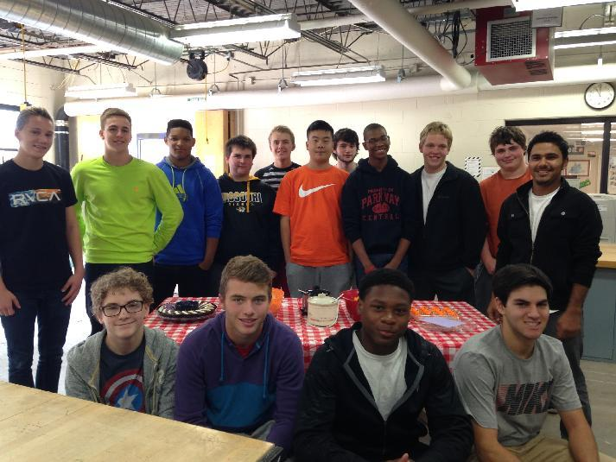

Thank you to Mr. Pannett's SHOP CLASS for building the picnic table for the show!



*Congratulations to the cast and crew for all of your hard work to bring us this production of   
Picnic.*

**Break a Leg.**

And a huge thank you to Mrs. Nicole Voss for the countless hours she spends in and out of class to inspire and teach our children all the aspects of theater -- lessons that will last their lifetimes.

- John and Sharon Kang

Director’s Note

It is my pleasure to present William Inge’s Pulitzer-Prize winning play Picnic. to our audiences, here at Parkway Central High. This play is a beautiful piece of work, illustrating how society has an impact on each one of us. The place and time – a rural town a half century ago – are the only things that date Picnic. Its themes of personal discovery, love, loneliness, aging, youth and the obsession with physical beauty are timeless and universal. I hope you can find your own truth, just as each one of these characters discovers their own. Please enjoy, Picnic.

Nicole Voss

Director

Speaking “Picnic”

The characters of Picnic communicate in an English somewhat unlike our own. Slang has changed immeasurably since the 1950s, and we can sometimes be perplexed when we speak with people of that era. Here are some of the terms and expressions in Picnic that may leave students scratching their heads:

***Dime Store***

Exactly what its name implies: a general store that stocks a variety of products for daily life, all for ten cents or less. In today’s era of super chains and changing prices, such an idea seems positively quaint.

***Floozy***

A flirt; a loose woman.

***Goon, Goon-face***

a hired thug; a brutish, dumb character, an epithet especially insulting to a girl in the era in which Picnic is set.

***Hoppin’ bells***

bringing hotel guests’ luggage from check-in to their room.

***I got rolled***

I got swindled, cheated.

***In a pig’s eye I did!***

Like hell I did! (Like heck I did!)

***Pauper’s Row***

The section of the cemetery in which people too poor to afford a headstone or casket were buried.

***She takes in every Tom, Dick and Harry***

the person talked about is being accused of indiscriminately housing whomever shows up looking for a place to stay. Few things could be more damaging to one’s reputation in the 1950s—especially to a woman—than being known for her poor judgment about whom to have in her house.

***Skedaddle***

To run away (especially after having committed an act liable to get one in trouble).

***The Stork Club***

Begun as a Speakeasy during Prohibition, the Stork Club became one of the most famous hang-outs of New York’s literati and of celebrities like Marilyn Monroe, Joe Dimaggio and Frank Sinatra.