**CAST LIST**

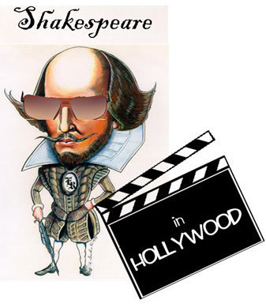

LOUELLA PARSONS…………………………...…Riley Cockerham

MAX REINHARDT…………………………………Chase Coleman

JACK WARNER………………………………….....Evan Mogley

DARYL………………………………………………...Dom Doray

LYDIA LANSING…………………………………...Skylar Droege

OBERON………………………………………………Anthony Blatter

PUCK.................................................…...Tatiana Kobasa

OLIVIA DARNELL………………………………....Emily Kang

WILL HAYES………………………………….…..…Will Harold

DICK POWEL/Albert……………………….…....Nick White

JOE E. BROWN/Harry……………………………Jeremy Alport

JIMMY CAGNEY/Sam……………………..….…Brett Smith

TARZAN/ensemble……………………….……...Anthony Devasto

COWBOY/ensemble………………………….....Jake Steinmetz

GROUCHO/ensemble……………………………Megan Baris)

ENSEMBLE………………………………………….…Jenn Harry

Darby Blum

Lauren Tubbe

Samantha Seigel

Chelse Baird