PRODUCTION SHOW PACKET

For Student and Parents of the

CAST



**Congratulations!**

You are now entering what will be one the best experiences of your high school career….the MUSICAL. What follows is important information that you need to know and complete for the production. Please do so within the next week and return all forms to the stage manager. Thank you for auditioning and being a part of this experience! We look forward to working with you!

**CAST**

TEVYE - Anthony Blatter

GOLDE - Aletha Bastin

TZEITEL – Skylar Droege

HODEL - Ariana Stein

CHAVA - Samantha Seigel

SHPRINTZE- Melanie Wilmert

BIELKE – Leah Kneznekoff

FRUMA-SARAH – Rebecca Velasquez

CONSTABLE – Chase Coleman

FYEDKA – Brett Smith

SHAINDEL – Sophie Orlet

THE MAMAS – Sophie Orlet, Darby Blum, Jenna Librach,

Rebecca Velasquez. Lee Foust

THE DAUGHTERS – Chelsea Baird, Lauren Johns, Megan Baris

THE RUSSIANS – Jenna Librach, Darby Blum, Lee Foust

THE STUDENTS - Darby Blum, Jenna Librach

THE FIDDLER- TBA

THE PRIEST – Guest Artists

LAZAR WOLF – Will Harold

MOTEL – Alex Kaiser

PERCHIK – Dom Doray

YENTE – Sydney Hirsch

MORDCHA – Nick White

RABBI – Mitch Broddon

MENDEL – Brett Smith

AVRAM – Chase Coleman

YUSSEL - Ray Burch

NACHUM – Rebecca Velasquez

GRANDMA TZEITEL – Lee Foust

**PRODUCTION TEAM**

PRODUCTION STAGE MANAGER - Stella Bauer

COMANPANY STAGE MANAGER – Mercedes McGonigle

PRODUCTION ASSISSTANT – Autumn Goldsby

MASTER ELECTRICIAN/LIGHT DESIGNER – Jonathan Scully

SOUND ENGINEER/SOUND DESIGNER– Juliana South

PROPS MISTRESS – Lee Gardunia

WARDROBE MISTRESS – Sophia Mackie

PUBLICIST – Athena Stamos

MAKEUP/HAIR – Roya Porshahidy

HOUSE MANAGER – Emily Kang

DIRECTOR - Nicole Voss

VOCAL DIRECTOR – Ben Silvermintz

CHOREOGRAPHER – Julia Wiegert

TECHNICAL DIRECTOR – Tara Stepanek

ACCOMPIANIST – Adam Rodgers

CONDUCTOR – Doug Hoover

SCENIC DESIGNER / BUILD – Chuck Winning

SCENIC ARTISTIS – Shannon Piwowarczyk

SOUND CONSULTANT – Doug Gardner

**PRODUCTION COSTS**

Students are required to pay a production fee in order to participate in the school play. This is necessary to cover the students’ individual costs. **Payment in full is due by December 16, 2016.** If there are financial concerns with the cost of the production fee, please talk to Mrs. Voss.

**Breakdown**

$15.00 t-shirt

$15.00 makeup kit

$10.00 dinner

$ 60.00 costume/dry cleaning

------------------

$100.00 total – make checks payable to PCH Musical

**IMPORTANT MUSICAL DATES**

**MANDATORY PARENT MEETING -** Wednesday, December 14; 7:00 pm

**MANDATORY REHEARSALS:**

Monday, January 16 – (12-5pm)– leads only + set crew

FEB 8 thru show dates: All conflicts from this day on, will not be honored. You are expected to be at all rehearsals regardless of your conflicts. If you normally have tutoring on Wednesday’s at 3pm, it now needs to be changed.

Friday, February 17 (no school)– Full run with Orchestra – (12 call/1pm go-6pm)– all cast called

Saturday, February 18 – Tech Rehearsal –(12:30 call/1pm go-6pm)– all cast called

Monday, February 20 – Dress Rehearsal – (12 call/1pm go/5pm dinner-8pm)– all cast called

Tuesday, February 21 – Dress Rehearsal (2:30call/3:00go/6pm dinner/7:30 pictures-10pm)– all cast called

**SHOW DATES**

Wednesday, February 22; school matinee 8:30-11:30am (call time: 7:00 am)

Thursday, February 23 7:00 pm (call time: 5:00 pm)

Friday, February 24 7:00 pm (call time: 5:00 pm)

Saturday, February 25 7:00 pm (call time: 5:00 pm)

Sunday, February 26 2:00 pm (call time: 12:00 pm)

**STRIKE** - Sunday, February 26; after the show ends until it is finished. MANDATORY, NON-NEGOTIABLE

All Cast and crew are required to help take the set down and put all costumes, props and supplies away. Students who leave early or need to make up strike will be required to do work in the theater or music department after school of equal time. Students who do not participate will not receive ITS points and/or it may hurt your chances at getting into Tri-M.

**St. Louis High School Musical Theatre Awards**: May 28, 2017 The Fabulous Fox (see packet for details)

**MUSICAL REHEARSAL GUIDELINES**

**REHEARSAL SCHEDULE**

Not every actor will be required to attend rehearsal everyday. **See the specific rehearsal schedule attached** to find out what characters are needed when. Rehearsals are typically Monday through Friday 2:45 to 5:30pm. Unless there are extenuating circumstances, all students scheduled to be at rehearsal are expected to remain there for the entire time. **The week of the show will consist of late and long hours for everyone involved in the production. Be sure your parents understand this before you audition for the show.**

**REHEARSAL ATTENDANCE**

The musical is a major extracurricular activity. If you are already participating in another major activity, you must be willing to compromise and keep up with your schoolwork. **YOU MUST ATTEND REHEARSALS!**

Be on time to rehearsal. If you insist on being late, we’ll ask you to withdraw from the show.

**We will be operating on a “3 Strikes – You’re Out!” policy. If you have 3 unexcused absences/arrive severally late/have to leave early from rehearsal – You will be Dismissed and/or Replaced.**

**REHEARSAL CONFLICTS**

Illness is an accepted excuse except in chronic illness during which you would miss more rehearsals than could be allowed. In the instance that you should become chronically ill and miss several rehearsals, your participation level in the musical may be altered (i.e. given a different role or removal from some dance numbers). Meetings, rescheduled (beyond normal daily scheduled) athletic practices, a rock concert, the movies, extended family vacations, birthdays, and other such events will NOT be valid excuses for missing rehearsals**. If in doubt about any of these things, check with Mrs. Voss.**

We are aware that the musical is a huge time commitment. Individual Conflicts will be honored up to Tuesday, February 7. Beginning Wednesday, February 8 it is expected that everyone is at rehearsals every day they are called. For example, if you normally have tutoring on Thursdays after school, then plan on canceling tutoring for Feb. 9 and 16!

**REHEARSAL BEHAVIOR**

Misconduct at rehearsals will not be tolerated. This includes, but is not limited to, complete disrespect for director or other production staff, destruction of props, horse-play, and removal of any items from theatre without permission from teacher/director. Any misconduct will result in dismissal from the production. While at rehearsals, students are required to always dress comfortable and **bring their scripts and a pencil to make notes**.

While we do the best we can to only call students to rehearsal when they are needed, inevitably things don’t always go as planned. It’s important that students are prepared to use their down time wisely. We suggest working on memorization of music, lines, or choreography. We also suggest that students bring homework so they may keep up with their studies. **Students should NOT use cellphones or IPODS** while at rehearsals. We want students to stay focused on their character and to pay attention to what is going on in the play. Students should stay in the rehearsal area and not wonder off.

**COMMUNICATION**

All cast and crew will be added to the GROUPME for the musical. Once you are added, you will start receiving important information about the production. Information can also always be found on the theatre call board, the musical office and the theatre department website. If you happen to leave school early due to illness and cannot attend rehearsal, YOU MUST CONTACT A STAGE MANAER OR VOSS OR SILVERMINTZ. A cast member is not acceptable to rely your message to us. See the rehearsal schedule for contact information.

**EVENING REHEARSALS**

The Monday and Tuesday of the week of the show is also commonly referred to as Hellweek. These are dress rehearsals, which will combine all the technical aspects of the show with the work of the cast. These rehearsals start right after school and could last as long as 11pm. It is our last chance to ensure that the performance is successful. This year, Monday is a holiday, so we will rehearse from 12pm until early evening. Students will have a dinner break around 6:30pm on both nights. Parents are encouraged to participate in a group dinner for all the students. Food contribution lists will be sent out to parents with plenty of notice.

**SCRIPTS**

You may write blocking and notes in your script books but only lightly in pencil. All books must be erased when returned or the company will charge an erasing fee, which we pass on to you. They usually charge about $10.00. Lost or late script books will cost you $25.00. If you return a script late, you bought it! It will then become a graduation obligation.

**MEMORIZATION**

It is expected that all students learn, practice and memorize all their lines, songs and choreography by the dates assigned. Start learning lines and songs right away.

**COSTUMES**

All students participating in the cast will be responsible for their shoes. Ladies are expected to have black or tan character shoes and gentlemen are expected to have black dress, dance or jazz shoes. If there are financial concerns with the cost of the shoes please see Mr. Silvermintz for confidential monetary assistance. The majority of the costumes for the show will come from our own stock, borrowed, bought or rented. However students may be asked to bring in items from their own wardrobe. Students are not required to purchase clothing but are responsible for undergarments such as pantyhose, socks, undershirts, etc. Parents may be asked to help build costumes. All students who wear any rented costumes will sign a “RENTAL CARE AGREEMENT” indicating what each actor is responsible for in their rental package, how to care for it and what the replacement cost is, if lost or damaged.

**PERFORMER APPEARANCE**

Performers may be asked to alter their appearance for a role. However, unless the director gives permission performers are not allowed to alter their appearance until after the final performance. This includes basic haircuts, hair dye, tattoos, piercing, etc.

**TECH WORK CALLS**

All cast and crew are expected to help with the technical aspects of the production during our Saturday work calls from 9am to 5pm. Additional set crew days meet on Mon, Wed. and Fri from 3-6pm. Special arrangements may be made for students with extenuating circumstances.

**ACADEMIC ELIGIBILITY / CODE**

It is expected that all students who participate in the musical are MSSHAA eligible which means that you may only have TWO Failing grades during the previous semester. You are expected to maintain your current semester grades as well.. In addition, all students will abide by the laws and rules regarding the use of alcohol and other illegal drugs as outlined by policies of the Parkway School District. Failure to maintain academic eligibility or your code of conduct may result in removal from the show.

**COSTUME AND MAKEUP REQUIREMENTS**

**MAKEUP:** Everyone must buy a makeup kit. Do not use an old kit from previous shows as it grows bacteria.

Order your makeup kit online using this Google form: <https://goo.gl/forms/TLjDSzSQdG5YNgTR2>

**HAIR:** NO ONE is to change their appearance unless specifically told to by the directors of this production. You may get a TRIM, but you may not CUT your hair in any way, shape, style or fashion!!! If you do, you risk being removed from the show. WIGS ARE NOT A MEANS TO COVER UP YOUR MISTAKES OR TO TAKE THE PLACE OF STYLE CUT. Wigs to the discretion of the director only… not you.

**COSTUMES:** Everyone will sign a “RENTAL CARE AGREEMENT” form as you are issued your costume. Failure to return your costume in proper condition (ie: tears, stains, etc) will result in additional fines to you.

**ALL MEN ARE RESPONSIBLE FOR:**

White or cream shirt, black or brown pants: loose fit around thighs/legs. You must wear pants at the waist, not the hips. Black jazz shoes or soft black dance shoes. Black socks and any other undergarments. Hair gel. Yes… many/most of you will be wearing beards or moustaches, so facial cream is a must.

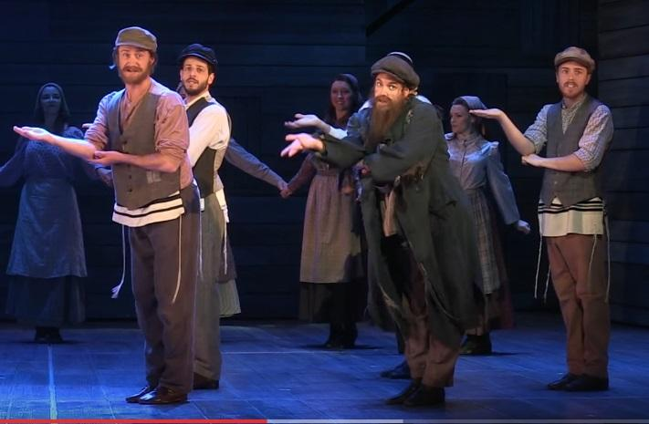

**ALL WOMEN ARE RESPONSIBLE FOR:**

Black opaque tights, Black flat booties (I have lots in the dept – 1st come), Hair accessories, & other undergarments.

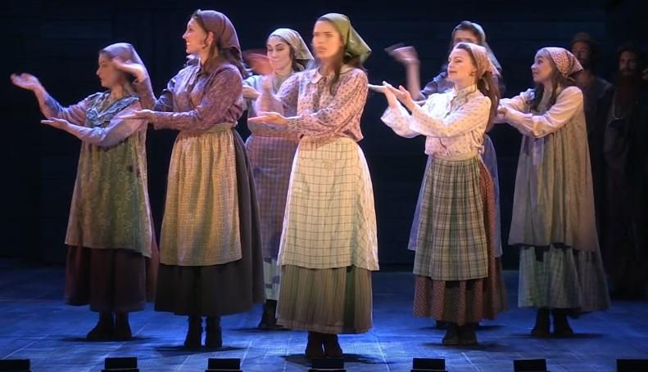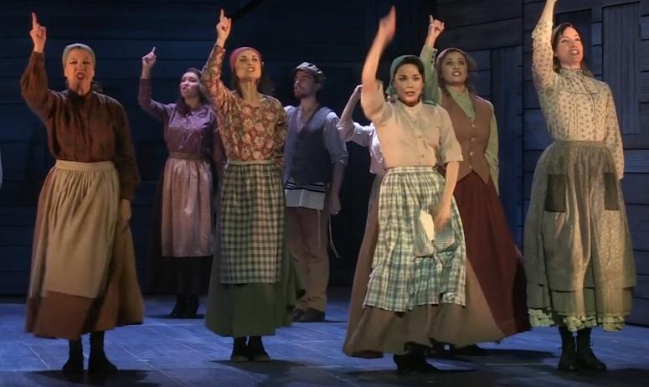

**CONTACT INFO**

Everyone needs to fill out the contact information so the stage managers can get hold of you in the event of an emergency or during school hours. Please include a CELL phone and parent contact as well!! Use this link: <https://goo.gl/forms/u7TFZZM5jMwW7MI53>

**PROGRAM BIOs**

All seniors will receive a bio in the program. If you are a senior, please go to this link and fill out your information that will be included in the program.

<https://goo.gl/forms/HfIMcc4gLs0Vxk4u1>

**Remember,**

**you, the student, agreed to…**

* pay the production fee of $100.00 that will go towards a t-shirt, my makeup and costume expenses.

* clear my schedule and attend ALL mandatory rehearsals for the entire length of time.

* I understand the “3 Strike” policy

* will have my conflicts listed on this sheet honored up until FEB 7. After Feb 7 I will clear my schedule of all conflict and attend all rehearsals. I understand that if any additional conflicts arise that are not listed here, they may NOT be honored.

* write in my script in pencil. I understand if lost or late there is a $25 fee and $10 erasing fee.

* take care of my rental costumes, and if damaged in any way I will pay the replacement cost

* not change my physical appearance in any way without first talking to the directors

* maintain my academic eligibility

* uphold my code of conduct in keeping with the policies of the Parkway School District

**Your parents agreed to….**

* do everything I can to support and help child with the above responsibilities

* not interfere with the casting decisions of the directors

* ensure that I am fully aware of the MANDATORY, NON-NEGOTIABLE dates and will make ensure my child is at those rehearsal dates.

* understand that rehearsals will conclude significantly later into the evening during the final week of preparation



The Fabulous Fox, The Muny, and Fox Performing Arts Charitable Foundation are very pleased to create the St. Louis High School Musical Theatre Awards (SLHSMTA), a regional chapter of the National High School Musical Theatre Awards. In this packet is a recap of the information we shared with you today. Please feel free to share this information with colleagues who were unable to be with us today.

The National High School Musical Theatre Awards (NHSMTA) impacts more than 50,000 students annually who participate in high school musical theatre competitions sponsored by top professional theatres throughout the United States. **A Best Actress and Best Actor winner** from each of these competitions is sent to New York for a week-long theatre intensive of coaching and rehearsals with industry professionals in preparation for a one-night-only showcase on Broadway, where a panel of judges crowns the nation’s top performers. Also known as The Jimmy Awards, named for Broadway impresario James M. Nederlander, the program has been the catalyst for more than $1,000,000 in educational scholarships. In 2012, the program inspired preeminent broadcaster WGBH Boston to produce a 3-part documentary series called “Broadway or Bust”, which follows students on a journey from their hometown competitions to their debut on Broadway. The series remains popular viewing at [www.pbs.org](http://www.pbs.org). For more information, please visit [www.nhsmta.com](http://www.nhsmta.com). Under ‘about us’ on the NHSMTA website is a list of approved shows and of qualifying leading roles.

The SLHSMTA program is designed to honor and celebrate high school musical theatre in our area. It will provide the opportunity for high school students to share their passion for this art form and to receive valuable feedback from theatre professionals through the adjudication process.

THE SLHSMTA EVENT

* The SLHSMTA will be held at The Fabulous Fox on May 28, 2017. It will be modeled on the Tony Awards.
* Each participating school will select two students to perform in the fully-choreographed Opening number and the Finale.
* Schools nominated for Best Musical will present one ensemble number as part of the ceremony.
* Nominees for Best Actress and Best Actor will perform in gender-specific medleys, specially arranged to highlight each performer in a solo moment.
* The winners of the Best Actress and Best Actor categories will enjoy an expense-paid trip to New York to compete in the NHSMTA program, which includes a week of coaching and rehearsals and culminates in a performance on a Broadway stage.
* Please visit nhsmta.com for more information about that experience.



**Program Advertising Form**

|  |
| --- |
| Name  _____________________________________________________________________________________________  Address City / State / Zip  ____________________________________________ _________________________________________  Work Phone Cell Phone Email  ________________________ ___________________________ __________________________________  ___________________________________ ________________________________ ________  Authorized by Signature Date |

|  |
| --- |
| **Please read carefully:**  * Be sure the contract is filled out completely.  * This ad will appear in the main stage production program.  * Black on white “Camera Ready” copy is preferred OR email to: nvoss@parkwayschools.net  * Do not staple, tape, bend or write on ad copy.  * Make a copy of this contract for your records.  * A finished copy the program will be sent to in the mail.  * Please include a check payable to PCH Theatre Department with the contract and the ad copy. Mail to:  ***Parkway Central High Theatre Dept. 369 N. Woods Mill Rd. Chesterfield, MO 63017*** |

|  |
| --- |
|  |

**Support the** 

**Performing Arts and….**

*“HAVE A SEAT”*

As a fundraiser for the PCH Theater, you have an opportunity to “purchase” a seat as a lasting tribute to your favorite musician, singer, band member, Thespian, family member or friend!

Brass nameplates will be permanently attached to each Donor’s seat. This can be a great tribute to a loved one, and makes a perfect holiday, birthday or graduation gift. Today, tomorrow and many years from now, whenever you come to enjoy Central’s productions, your “signature” seat will still be there. What a great honor to remember that special child, teacher, friend or relative!

Each seat contribution is $100 each and is **TAX-DEDUCTIBLE**. Please make checks payable to the PCHS Seat Fund. A personal certificate is provided with each donation. Share the excitement for excellence in performance art at PCHS and “HAVE A SEAT!”

Complete the order form and returned to Mrs. Voss in the Theatre Department. Orders received by April 15th of each year will be installed prior to the Theatre and Music banquets. Orders received thereafter are NOT guaranteed installation by banquet but will be installed before the next school year.

-------------------------------------------------------------------------------------------------------------------

*HAVE A SEAT* ORDER FORM

Donor’s Name: _______________________________________________________________________________

Address: _________________________________________ City, State, Zip: ______________________________

Home Phone: (_____) _______________________________ Work Phone: (_____)_________________________

**INSCRIPTION INFORMATION**

____ In Honor of ____ In Memory of Class of ________ (PCH Grad)

_____________________________________________ (name of recipient)

_______________________________________________________________________________________

(optional line inscription - limit 25 characters)

Return to: PCHS School Book Store or mail to:

369 North Woods Mill Rd. Chesterfield, MO 63017

Attn: PCH Seat Fund / Nicole Voss

*THANK YOU FOR SUPPORTING THE PERFORMING ARTS!*

**PARENT VOLUNTEER FORM**

**Parents**: In order for us to have a successful production, we need the help of our parents… both theatre AND music parents!!!! Please fill out the following information and return to Mrs. Voss ASAP. You may also email me if that is more convenient. [nvoss@parkwayschools.net](mailto:nvoss@parkwayschools.net)

**Parent Name: _______________________________________________________________________** **Facebook ___Y ____N**

**Parent Cell: _________________________________________ Parent E-mail: ________________________________________**

**Student Name: _______________________________________ Role ____________ Current Grade: ________________**

***GENERAL VOLUNTEER ACTIVITIES WHERE WE COULD USE SOME HELP…***

_____ Set construction _____ Sewing / Costuming  _____ Cooking/baking

_____ Public Relations _____ Other ________________________________________

**FIDDLER ON THE ROOF– FEB 23-25 @ 7pm FEB 26 @ 2pm 2017**

**Yes, I would be willing to sign up to help on the following dates….**

Concessions - (involves selling baked goods before the show and during intermission)

_____ Feb 23 _____ Feb 24 _____ Feb 25 _____ Feb 26

Rehearsal Meals - (participating in preparing the dinner for the cast and crew on the two late nights)

_____ Feb 20 _____ Feb 21

Box Office - (involves helping to sell tickets before the show)

_____ Feb 23 _____ Feb 24 _____ Feb 25 _____ Feb 26



**RESERVED TICKET ORDER FORM**

**Parent Name: ________________________________________ Address: _________________________________________________**

**Parent Cell: _______________________________ Parent E-mail: _________________________________ order date: ___________**

Tickets are $8.00/students, $10/senior citizens (65+) and $12.00/adults. **UNFORTUNATELY, NO COMPS ARE GIVEN TO ANYONE FOR THE MUSICAL** Tickets will go on sale to the public 2 weeks prior to opening night. Tickets can be purchased during all lunch shifts or may be phoned into the box office: 415-5944. ALL RESERVED TICKETS MUST BE PAID IN ADVANCE, AT LEAST THREE DAYS PRIOR TO THE DATE OF PERFORMANCE. Phone ticket reservations made on the day of a performance will be held until 15 minutes prior to curtain. Thereafter, all reservations will be released. Make checks payable to the PCH THEATRE. All ticket orders for cast/crew/orchestra must be accompanied with this form and payment.

Thursday FEB. 23 @ 7:00

__________ @ $8.00 = _________________

__________ @ $10.00 = _________________

__________ @ $12.00 = _________________ $_____________

Thr. tix subtotal

Friday FEB 24 @ 7:00

__________ @ $8.00 = _________________

__________ @ $10.00 = _________________

__________ @ $12.00 = _________________ $_____________

Fri. tix subtotal

Saturday FEB 25 @ 7:00

__________ @ $8.00 = _________________

__________ @ $10.00 = _________________

__________ @ $12.00 = _________________ $_____________

Sat. tix subtotal

Sunday FEB 26 @ 2:00

__________ @ $8.00 = _________________

__________ @ $10.00 = _________________

__________ @ $12.00 = _________________ $_____________

Sun. tix subtotal

TOTAL NUMBER OF TICKETS: ________

TOTAL AMOUNT DUE $ _____________________

PAID: CASH CHECK #________________