Chapter 7.1-7.3 Quiz A Exponential Expert___________________
No Calculator.
Determine if the equation represents an exponential growth or decay. Explain why.
1.) 2.)

____________________________ ____________________________

____________________________ ____________________________

3.) 4.)

____________________________ ____________________________

____________________________ _____________________________

Graph each of the following. Give the equation of the asymptote and state the domain and range. Label at least two points.
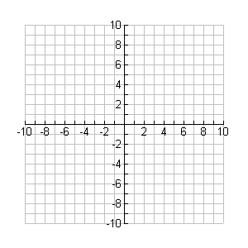
5.) 6.)

Asymptote:__________ Asymptote:___________
Domain:___________ Domain:_____________
Range:___________ Range:_____________

Chapter 7.1-7.3 Quiz A Exponential Expert____________________

Calculator.

Use the following formulas to answer the problems below.

1.) You buy a commemorative coin for $110. Each year the value of the coin increases
by 4%.

Equation:____________________

How much is the coin worth after 10 years?_________

2.) You buy a stereo system for $750. Each year the value of the stereo system decreases
by 5%.

Equation:_______________________

How much is the stereo system worth after 3 years?__________

3.) You deposit $1600 into a bank account that pays 2.5 % interest compounded
continuously.

Equation: ______________________

What is the balance after 3 years?________________

When will the balance reach $2000._________________

4.) You deposit $2500 into a bank account that pays 5% interest compounded quarterly.

Equation:______________________

What is the balance after 4 years?________________

When will the balance reach $4000._______________

