HAT
2nd Semester Final Review

1. Simplify:

a) -4 b) 8 c)-8 d) e) -

2. Simplify the radical expression:

a) b) c) d) e) NOT

3. Rationalize the demonimator:

a) b) c) d) e) NOT

4. Solve:

a) x = b) x = c) x = d) x = e) NOT

5. Perform the multiplication and simplify:

a) b)

c) d) e) NOT

6. Perform the division and simplify:

a) b)

c) d) e) NOT

7. Perform the subtraction and simplify:

a) b) c) d) e) NOT

8. Determine the domain of the function

a) All Reals except x = -2 and 1
b) All Reals except x = 1
c) All Reals except x = -2 and -1
d) All Reals except x = 2 and 1
e) All Reals

9. Find the vertical asymptote(s):

a) x = -2, x = 5 b) y = 1 c) y = 0 d) y = 1, y = 0 e) NOT
10. Find the horizontal asymptote(s):
a) y = 1 b) y = 0 c) x = 1 d) x = ±1 e) NOT

11. Find the horizontal asymptote(s):
a) x = 4 b) y = 0 c) y = 7 d) x = 0 e) NOT

12. Find the domain:
a) all reals b) all reals except x = 2 c) all reals except x = 1

d) all reals except x = 1, 2 e) NOT

13. Find the real zeros of f:
a) b) c) ±1 d) e) NOT

14. Find the intercepts of:
a) (0, -2), (14, 0) b) (-14, 0) (, 0) c) (14, 0) (0, )

d) (14, 0) (0, ) e) NOT

15. Graph:

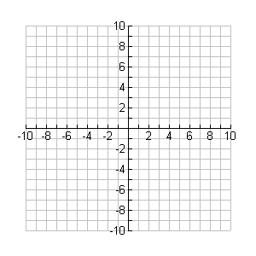

16. Find the slant asymptote of:
a) y = 1 b) y = x + 7 c) y = x – 8 d) y = x + 1 e) NOT

17. Evaluate:
a) b) c) -3 d) 3 e) NOT

18. Evaluate:

a) b) c) -3 d) 3 e) NOT

19. Evaluate , given that

a) 1.1631 b) 0.2466 c) 0.0349 d) 1.4420 d) NOT

20. Solve for x:

a) b) c) d) e) NOT

21. Solve for : ln (7 – x) + ln (3x + 5) = ln ( 24x)

a) b) c) d) e) NOT

22. Graph:

23. Graph:

24. Determine the quadrant in which the terminal side of an angle of 215° lies.

a) I b) II c) III d) IV e) It is quadrantal

25. Give the reference angle for

26. Give the exact value of sec

27. Graph:

28. Evaluate: arcsin 0

a) b) c) 0 d) e) NOT

29. Evaluate sin(arctan )

a) b) c) d) e) NOT

30. Add and simplify:

a) b) 0 c) 2 cot x csc x d) 2 csc ² x e) NOT
31. Simplify:

a) b) c) 2 tan² x

d) tan² x + 2 e) NOT

32. Find all solutions in the interval [0, ): 2 sin² x - 2= 0

a) 0, b) c) d) e) NOT

33. Given triangle with A = 47º, B = 63º, and c = 123, find a.

a) 88.6 b) 95.7 c) 82.6 d) 112.1 e) NOT

34. Given triangle with A = 74º, a = 59.2, and c = 60.3, find the two possible values of B.

a) 78.3º, 101. 7º b) 4.3 º, 27.7 º c) 73.7 º, 106.3º d) 32.3º, 0.3º

e) NOT

35. Given triangle with a = 19, b = 4, c = 22, find C.

a) 117.4º b) 132.1º c) 87.2º d) 99.7º e) NOT

36. You throw your gum into the street and watch as a car runs over it and the gum gets stuck in the tire. You watch the gum as it goes round and round, making one revolution every 3 seconds. You estimate the tire is 36 inches in diameter. Being incredibly bored that day, you would like to find the formula of the path of the gum so that you can tell anyone who asks where the gum is given the time it has traveled. Which of the following would be that formula:

a) f(x) = 18 cos +18 b) f(x) = -18 sin+18 c) f(x) = -18 cos +18

d) f(x) = 18 sin+18 e) NOT

ANSWERS:
1. D
2. B
3. B
4. A
5. B
6. D
7. D
8. B
- A
- A
- B
- E
- A
- A
15.
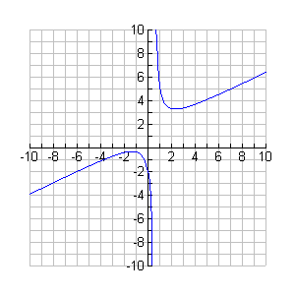
16. B
17. C
18. B
19. A
20. C
21. B

22.

23.

24. C
25. C
26. A
27.

28. C
29. D
30. D
31. B
32. C
33. B
34. B
35. E
36. C

