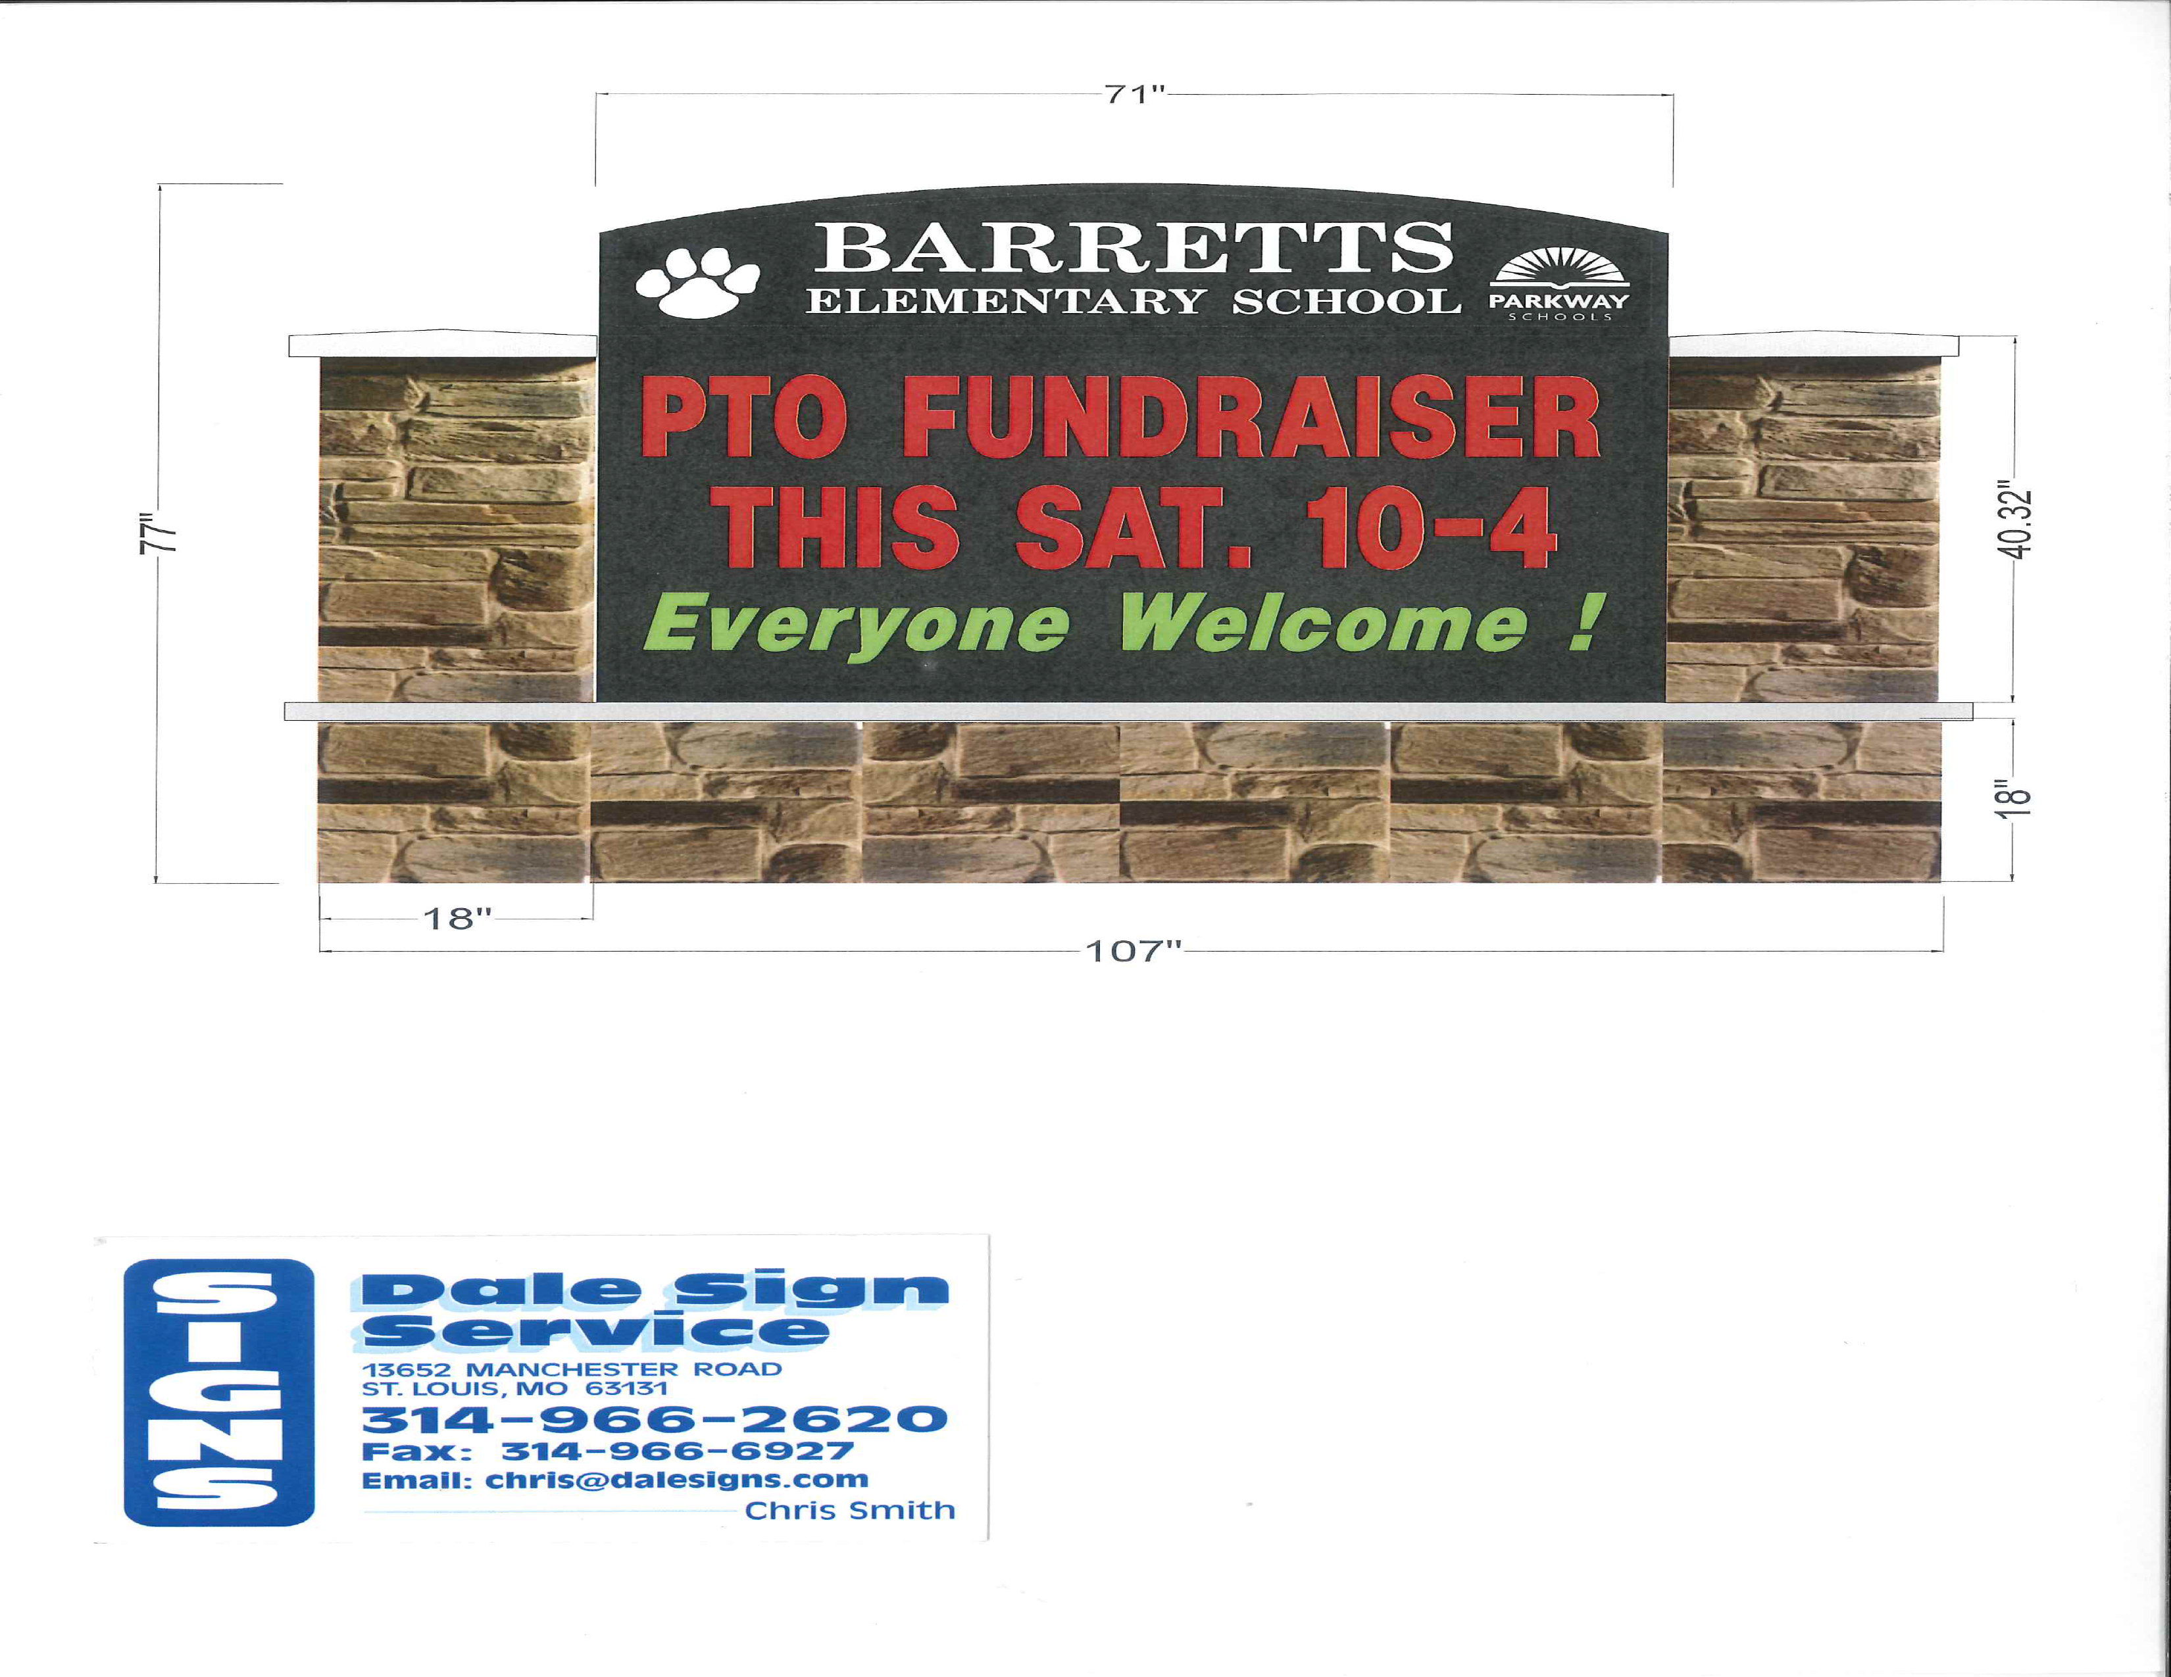

**Do you want to leave a legacy at Barretts Elementary??**

By purchasing this custom 4”x8” or 8”x8” brick you will be helping to complete the stone/masonry surround for our new LED sign that will be installed this summer!  Your brick will be placed in a pathway around the new sign.  Help us raise the extra funds needed to make the new sign look amazing!

Barretts bricks are available in two sizes – 4”x8” or 8”x8”. Engraved on your custom brick could be:

· your family name · a student or alumni's name and year of graduating   
class · your organization name · in honor of someone special · gratitude   
for a favorite teacher · in memory of a loved one ·

Please purchase your brick onlinevia Bobcat Central at: <http://barrettselementary.schoolauction.net/201617>.

4”x8” Brick = $75 8”x8” Brick = $125  
2 lines of text (21 characters per line) 4 lines of text (21 characters per line)

***Complete*** the form below to personalize your message. A separate form is required for each brick if ordering multiple bricks.

***Return*** completed form(s) to the school office or mail with your check made payable to   
Barretts Elementary PTO to: Barretts Elementary School, 1780 Carman Road, Manchester, MO 63021

The ***deadline*** for ordering is May 31, 2017. Donations for Barretts bricks are tax-deductible. Questions? Please contact Jennifer McGillivary at [jtmcgillivary@gmail.com](mailto:jtmcgillivary@gmail.com) or (314) 835-1835.

Name: _____________________________________________

Phone: _____________________________________________

Email: ______________________________________________

Personalize for 4”x8” brick:

|  |  |  |  |  |  |  |  |  |  |  |  |  |  |  |  |  |  |  |  |  |
| --- | --- | --- | --- | --- | --- | --- | --- | --- | --- | --- | --- | --- | --- | --- | --- | --- | --- | --- | --- | --- |
|  |  |  |  |  |  |  |  |  |  |  |  |  |  |  |  |  |  |  |  |  |

|  |  |  |  |  |  |  |  |  |  |  |  |  |  |  |  |  |  |  |  |  |
| --- | --- | --- | --- | --- | --- | --- | --- | --- | --- | --- | --- | --- | --- | --- | --- | --- | --- | --- | --- | --- |
|  |  |  |  |  |  |  |  |  |  |  |  |  |  |  |  |  |  |  |  |  |

Additional text for 8”x8” Brick ONLY:

|  |  |  |  |  |  |  |  |  |  |  |  |  |  |  |  |  |  |  |  |  |
| --- | --- | --- | --- | --- | --- | --- | --- | --- | --- | --- | --- | --- | --- | --- | --- | --- | --- | --- | --- | --- |
|  |  |  |  |  |  |  |  |  |  |  |  |  |  |  |  |  |  |  |  |  |

|  |  |  |  |  |  |  |  |  |  |  |  |  |  |  |  |  |  |  |  |  |
| --- | --- | --- | --- | --- | --- | --- | --- | --- | --- | --- | --- | --- | --- | --- | --- | --- | --- | --- | --- | --- |
|  |  |  |  |  |  |  |  |  |  |  |  |  |  |  |  |  |  |  |  |  |

**Engraving Examples:**

***4”x8” 4”x8” 8”x8” 8”x8”***

The Miller Family In Memory of Sam Smith Girl Scout Troop 1795

Class of 2022 and 2025 [Name] Class of 2015 2014 – 2020

Jane Smith Julie, Sara, Emma, Jill,

Class of 2017 Tara, Amy, & Maddie

